**LIVWELL: A RENTAL PROPERTY E-COMMERCE   
AND MANAGEMENT SYSTEM**

A Thesis

Presented to the Faculty of

**Computer Studies Department**

College of Science

Technological University of the Philippines

Ayala Boulevard, Manila

**By**

**Cujardo, Gwynn R.**

**Florendo, Cyrus Nathaniel P.**

**Jaime, Jewel Vaida A.**

**Quiambao, Aeron Justin C.**

**Salangsang, Arsenic M.**

**In Partial Fulfillment of the**

**Requirements for the Degree**

**Bachelor of Science in Information System**

**2024**

**TABLE OF CONTENTS**

**PRELIMINARIES**   **Page**

Title Page i

Table of Contents ii

List of Figures iii

List of Tables iv

Chapter 1THE PROBLEM AND ITS SETTING 5

Introduction 6

Background of the Study 7

Objectives of the Study 10

Significance of the Study 12

Scope and Limitations 13

Chapter 2CONCEPTUAL FRAMEWORK 15

Review of Related Literature 16

Synthesis of Review of Related Literature 36

Review of Related Studies 38

Conceptual Model of the Study 41

Operational Definition of Terms 44

Chapter 3METHODOLOGY 45

Project Design 45

Project Development 70

Operating and Testing Procedure 72

Evaluation Procedure of the Study 79

REFERENCES 82

# Chapter 1 THE PROBLEM AND ITS SETTING

## Introduction

The Philippines, being an archipelago of over 7,000 islands, is a home to many residential dwellings. From single-family homes to high-rise condominiums, a vast variety of options are available to cater to the diverse needs and preferences of the population. It is a major milestone for most people to purchase a house and is often considered as a symbol of stability and success. However, in recent years, customers' preferences have shifted toward renting rather than buying. This transition can be linked to a variety of factors, including the increasing cost of homeownership, changing lifestyles, and the flexibility that renting provides (Statista, 2024).

As the field of information technology continues to expand, e-commerce has become a viable business opportunity, revolutionizing the way people shop. E-commerce platforms allow consumers to shop online and pay online, without the need of face-to-face interaction, through the Internet at the comfort of their home, saving time and space, particularly in enterprises, enhancing transaction efficiency. Furthermore, this virtual marketplace offers a wider selection of products and services than ever before, opening new opportunities that extend beyond traditional product sales like property rentals.

Finding suitable and affordable accommodation, whether for rental or for permanent residence, is a crucial challenge for many individuals, as more people migrate to urban areas, like Manila, in search of employment and better opportunities. However, with the emergence of advanced technology, web applications and systems that facilitate property searches can make these tasks simpler. Additionally, putting concepts like management into the digital realm facilitates communication and streamline tasks such as rent collection, requests, and lease agreements, between the property owner and potential tenant, allowing a smoother and more efficient process.

Fortunately, the proposed system can help individuals locate available rental properties and help owners promote and manage their units efficiently. With the utilization of the agile scrum methodology and quantitative research method, the researchers aim to achieve the desired outcome of the study.

In conclusion, as more people flock to urban areas in the Philippines and preferences for housing evolve, there is a growing need for innovative solutions in the rental market. This research project introduces a system that harnesses the power of e-commerce and advanced technology to make the search for tenants easier and property management smoother for property owners. By offering a user-friendly approach, this system can ease the challenges of finding the right accommodation in a competitive market, benefiting property owners and tenants.

## Background of the Study

The concept of renting properties in the Philippines is a process that will always be familiar to the Filipino community, as people of any stature are exposed to this process as it involves the livelihood of the people. Renting is divided into two main categories, short-term and long-term rentals, and with different uses, benefits, and drawbacks, the type of category that one will use depends on the factors surrounding that property. In terms of finding a place to live well in or grow a business wherein the space is advantageous, long-term renting with leases are usually the standard in this category. Thus, this simple and common yet flourishing concept of renting continues to play a crucial role in shaping the housing market and providing stable accommodation options for individuals and businesses in the Philippines. Unlike short-term rentals, which cater to transient needs, long-term rentals involve contractual agreements spanning months or even years, offering tenants the stability and security needed to establish their living space or sustain business operations.

As people began to recognize the value of real estate, they saw opportunities in land and housing. Many nurtured and supported this process, leading to its development into what it is today. In the context of the Philippine rental market, long-term rentals are the cornerstone of residential, commercial, and even industrial property transactions. Together with fixed leases, these rentals provide tenants with a sense of permanence, allowing them to create a temporary home or establish businesses within an environment that is stable and strategic. For property owners, long-term rentals offer steady income streams and the opportunity to cultivate enduring symbiotic relationships with the property's tenants.

Real estate is a tangible asset made up of the property and the land on which it sits, and while it is immovable, real estate, like other assets, is also subject to supply and demand. This means that the prices of properties and their rent depend heavily on the law of supply and demand. Thus, the more demand, prices rise; the more supply, prices fall. To understand the process of renting is to learn its essential concepts, as the process of long-term renting involves parties that work together to form a sustainable and beneficial relationship. Renting is an uncomplicated process with many key steps. Beginning by first marketing your property, whether it be locally or online, the times today provide numerous opportunities to highlight your property no matter the distance. Potential suitors then contact the property owner through various means, creating a point of contact that is essential in determining the future of that rental property. Leading to the agreement and the formation of contracts or leases that decide how the rental agreement will continue and amend issues that may arise.

Mentioned are the many factors that work together to form a successful rental property, and some of these factors are not always in good condition. Such are the reasons why disputes and issues occur in the highly marketable rental space. In the area of property listing, many websites and platforms have been created to handle long-term renting of properties yet there has been no consistent and well-known brand contrary to the space of short-term renting of properties. This has led to a more tedious and time-consuming process for both the property owner and the potential tenants. Regarding property management, there is also no well-known service that handles long-term renting indicating a need to fill in a crucial gap that will ease the process of observing and analyzing your properties, helping property owners plan and strategize better. The management of properties can also help in allowing contact between owner and tenant, creating a consistent means of communication serving as a streamlined way of being up to date with matters that concern the parties’ livelihood. By leveraging technology and data analytics, these platforms can provide property owners with valuable insights helping create better and optimized decision-making. Moreover, while technology has undoubtedly facilitated the rental process in many ways, it may also introduce new complexities and challenges. Combining the two concepts of listing and management will aid in making a platform that encourages customer retention and customer satisfaction.

In conclusion, the rental market in the Philippines presents significant opportunities for innovation and growth. With the increasing urbanization and economic development in the country, demand for quality rental properties is on the rise, presenting an opportunity for services to capitalize and develop integrated rental platforms that streamline the entire rental process, from property listing and accessibility to lease and complaint management. By providing sustainable and accessible solutions, fostering innovation and collaborative relationships, the proper platform can unlock and begin the potential of the rental space, contributing to a better experience for everyone involved.

## 

## Objectives of the Study

***General Objective***

The study's main objective is to develop a rental property e-commerce and management system through a website application catering to property owners and tenants. The platform allows property owners to list and manage their rental properties and allows tenants to explore available rentals.

***Specific Objectives***

The following are the specific objectives of the study:

1. Create and design the system with the following characteristics:
2. A platform for property owners to list their properties that are available for rent.
3. A platform for property owners to manage their rental properties.
4. A platform for prospective tenants to easily find properties that align with their preferences.
5. A platform for tenants to file a complaint about the property or report issues to the property owner.
6. To locate the specific location of the listed property on the map, the system will use the Google Maps API.
7. The system will use data analytics to help property owners gain valuable insights.
8. Create the website application using the following software development tools and scripting language:
9. Front-end tools

* HTML
* JS
* CSS
* Vue

1. Back-end tools

* Python

1. Framework

* Django

1. Database Management System

* MySQL

1. Version Control

* GitHub

1. IDE

* Visual Studio Code

1. User-Interface Tools

* Adobe XD

1. Test and improve the website application based on functional suitability and reliability
2. Evaluate the acceptability of the website application by gathering multiple users to operate the system. The tool that will be used to evaluate the application is ISO25010, which will evaluate the application's acceptability in terms of sustainability, timeliness, accuracy, and maintainability.

## Significance of the Study

Renting diverse types of properties has become an essential solution for individuals and businesses seeking flexible and convenient living and working arrangements.

For property owners, the web-based system will offer a platform to list and manage their properties efficiently, thereby modernizing their operations. For tenants, the system will provide a practical tool to easily find available rental properties, making the search process more efficient and providing access to comprehensive resources and information about the properties.

Finally, this capstone project will be valuable for future researchers. It can serve as a reference to enhance future studies with similar objectives, and future researchers can build upon the data and features introduced in this study, thereby solidifying, and expanding the work initiated by the current researchers.

## Scope and Limitations

This study centers on the development of an e-commerce and management system website dedicated to showcasing properties in the Philippines. It endeavors to provide property owners with a robust platform to exhibit their rental properties, enabling them to effectively connect with potential tenants. Through a user-friendly interface, property owners will have the flexibility to create, update, customize, and remove their listings within the system, ensuring accurate representation and efficient management of their properties.

In addition to serving property owners, this study strives to address the pressing needs of tenants, particularly students or individuals seeking suitable accommodations close to their educational institutions or workplaces. By facilitating easier access to rental options, this initiative aims to enhance convenience and streamline the property search process for prospective tenants, thereby fostering a more seamless transition into their new living arrangements or commercial spaces. ￼

This study's overarching goal is to foster mutual benefits for both tenants and property owners alike. By leveraging advanced search functionalities and customizable filters, tenants can pinpoint properties that align closely with their preferences, budgetary constraints, and lifestyle requirements. Simultaneously, property owners stand to gain increased visibility and exposure for their rental properties, thereby maximizing their potential for occupancy and revenue generation.

The e-commerce and management system website are meticulously crafted using a diverse array of innovative web development technologies and frameworks, including but not limited to Python, HTML, JS, CSS, Vue.js, Django, MySQL, GitHub, Visual Studio Code, and Adobe XD. By harnessing the power of these tools, the platform offers unparalleled scalability, reliability, and performance, ensuring a seamless user experience across various devices and browsers.

Moreover, the system's web-based architecture eliminates the need for cumbersome downloads or installations, providing users with instant access to its full suite of features and functionalities directly through popular web browsers such as Chrome, Safari, Firefox, Opera, and Edge. By implementing stringent security measures and encryption protocols, the platform safeguards sensitive user data and ensures uncompromising privacy and data integrity.

Users are encouraged to create personalized accounts to unlock exclusive access to premium features and detailed insights into the listed properties within the system. Property owners can leverage their accounts to display their rental properties to a broader audience, while also gaining invaluable insights into market trends, demand dynamics, and competitive pricing strategies.

Furthermore, the platform adopts a seamless user experience design, allowing users to seamlessly transition between distinct roles and functionalities with minimal friction. Whether users are property owners seeking to list their properties or tenants searching for their next ideal rental, the platform offers intuitive navigation and robust backend support, empowering users to achieve their respective objectives with ease and efficiency.

# Chapter 2 CONCEPTUAL FRAMEWORK

This chapter presents the related literature, studies, and systems, a synthesis of the whole literature review, the conceptual model of the study, and the operational definition of terms relevant to LivWell: A Rental Property E-Commerce and Management System.

## Review of Related Literature

This part contains related literature of the LivWell: A Rental Property E-Commerce and Management System.

***Renting***

Renting is to allow someone to use and occupy something in exchange for regular payments (Merriam-Webster, n.d.). Similarly, Santander (n.d.) defines renting as the long-term leasing of fixed assets such as vehicles, office equipment, or computer systems. These contracts have a fixed term with set installments that remain consistent throughout the lease. Additionally, these agreements typically include costs for maintenance, insurance, and other related expenses. Rental housing may be only a partial answer to urban housing problems, but it is an important housing option (Khan and Scholtz, 2011).

Renting a property offers several advantages, particularly for businesses and individuals looking for flexibility and cost efficiency. According to Khan and Scholtz (2011), renting provides mobility, allowing individuals to relocate easily for job opportunities without being tied down to a specific location or regular renting payments. This flexibility extends to managing budgets, enabling people to move to more affordable space during tough times or upgrade when their financial situation improves. As mentioned by Majaski (2024), when you rent, your monthly expenses are clearly defined in your lease agreement, allowing you to budget with certainty. Lastly, renting is particularly advantageous during transitional periods of life, such as when individuals are not ready to settle in one place (Khan and Scholtz, 2011).

In conclusion, renting emerges as a versatile solution for residential accommodations and commercial spaces, offering businesses and individuals the flexibility to adapt to changing needs and seize new opportunities. Its significance extends beyond mere shelter, providing a vital avenue for mobility, budget management, and transitional support in an ever-changing urban landscape.

***Rental Property as an Income***

Operating rental property is considered a business when undertaken to generate profit and consistently dedicating time and effort to its management (Fisherman, 2019). According to Caltabanis (2019), rental properties are designed to make money through tenants' rent payments, and they are also a popular investment choice because they provide steady rental income and the chance for the property's value to increase. As a solution to the rising demand for both residential and commercial spaces in urban areas, many individuals utilize their properties by offering them for rent, effectively establishing rental businesses in both sectors.

The current study aims to collaborate with property owners to list their unoccupied properties for rent on the website, allowing tenants to easily search and access comprehensive details of the properties available for rent.

***Different Types of Rentals***

Rental properties vary in their characteristics, encompassing different property classes distinguished by location, structure, size, and management type (What types of residential properties are there?, 2022). This classification is further supported by "The Many Types of Rental Properties" (2022). Examples of rental properties encompass several types of real estate (Caltabanis, 2019). The types of real estate include:

* Single-family homes: dwellings that do not share walls or land with another dwelling and have their own entrance and exit.
* Multi-family homes: single buildings divided into multiple housing units, containing between two and four rental units.
* Commercial Properties: properties used for business activities, encompassing everything from office and industrial spaces to retail and apartment buildings.
* Specialized Properties: short-term rental properties rented temporarily to tourists, vacationers, or students. Examples include housing, senior living communities, and vacation homes.

The current study has considered and understood the distinct types of rental properties. The current study will apply this understanding in filtering the search, which will assist tenants in finding the right property for them.

***Web-based System***

In an article written by (Senthil, 2024), in the past, web-based applications had limited functionality, but improvements in technology, security, and internet speed have significantly expanded the possibilities for web-based systems. A web-based system is an application that you access using HTTP, typically describing applications that operate within a web browser. A web-based system is an application that you access using HTTP. Typically, it is used to describe applications that work in a web browser. Web-based systems are accessible anywhere and have lower development costs, increased efficiency, and reduced hardware costs.

The current study proposed an e-commerce and management system web-based because of its accessibility, that can be accessed if there is an internet connection and browser.

***Data Analytics***

Based on an article by The Investopedia Team (2024), data analytics is the science of examining raw data to draw conclusions. Shao et al. (2022) added that data analytics involves estimation, statistics, organization, user experience, and computing technologies, encompassing various theoretical and statistical methods and trends. According to Ghasemaghaei (2019), data analytics use refers to how many companies use technologies designed to efficiently get useful information from substantial amounts of diverse types of data. Moreover, data analytics tools help share and improve knowledge. Finally, using advanced data analytics tools is key to better decision-making.

The current study will employ data analytics in a web-based system to assist property owners by providing valuable insights and improving various aspects of property management.

***Google Maps API***

Google Maps API are open-source codes in the Google Maps Developer Console, which are used in map-based solutions for different purposes (Basarsoft, 2023). Similarly, Juviler (2022) mentioned that the Google Maps API enables developers to utilize Google Maps data and features in their projects. Moreover, according to Muñoz-Villamizar et al. (2021), Google Maps API is a free web mapping tool that provides access to up-to-date and precise geographical information and spatial analysis. Additionally, it allows developers to embed interactive maps on their websites and customize them according to their needs.

The current study will employ the Google Maps API in the web-based system. It will play a pivotal role in enhancing the user experience for prospective tenants. By integrating the Google Maps API into the system, tenants will have the visualization of the precise locations of listed properties.

***Adobe XD***

Adobe XD is a tool that uses vector graphics to help user experience (UX) designers and user interface (UI) designers make realistic, interactive digital interfaces for websites and mobile apps. It was designed to offer features that are specifically useful for interface design (Myre, 2022). According to The Upwork Team (2022), Adobe XD has many features and uses, making it an essential tool for any UX and UI designer. In addition, an article entitled "What is Adobe XD?" (2024), mentioned that Adobe XD not only aids in the design process but also fosters collaboration among design teams and others through integration with platforms like Slack and Microsoft Teams.

The current study will employ Adobe XD in the user interface design phase to create and test interactive prototypes. This approach aims to streamline the design process, enhance collaboration among team members, and ensure that the final product meets user expectations. By leveraging Adobe XD's robust set of tools and its integration capabilities with collaboration platforms, the study seeks to demonstrate the effectiveness of this software in producing high-quality, user-centered designs while facilitating seamless communication and cooperation within the design team.

***Visual Studio Code***

Visual Studio Code, often abbreviated as VS Code, is a free, lightweight, yet powerful source code editor available for Windows, macOS, Linux, and Raspberry Pi OS, running on both desktop and web platforms (Heller, 2022). According to Chris (2023), VS Code is like Sublime Text and Atom, offering a rich text editing experience like a miniature version of Visual Studio. VS Code provides developers with a customizable environment through various plugins, making it versatile and adaptable to different programming needs (Your Ultimate Guide To Visual Studio vs Visual Studio Code, n.d.). Lastly, Heller (2022) mentioned that VS Code has built-in support for JavaScript, TypeScript, and Node.js, along with a vast ecosystem of extensions for other languages, runtimes, environments, and clouds, catering to a wide range of development tasks.

In the current study, Visual Studio Code, or VS Code, will serve as the IDE (Integrated Development Environment) due to its compatibility with various programming languages required for the development of the web-based system. Additionally, its rich ecosystem of extensions can aid in debugging tasks. Lastly, the researchers' familiarity with VS Code further supports its selection as the preferred IDE.

***GitHub***

GitHub, an online interface, facilitates real-time collaboration among users (Coursera, 2023). According to Lutkevich and Courtemanche (2023), it serves as a web-based version control and collaboration platform primarily targeted at software developers. The platform's expansive features redefine the collaborative landscape for software development projects, extending beyond mere code storage to encompass version control, issue tracking, and code review functionalities, all crucial components in contemporary software development processes (Webb, 2024).

GitHub claims that it is utilized by over four million organizations and more than one hundred million developers (GitHub, n.d.). Webb (2024) notes that GitHub's popularity among software developers stems from its comprehensive feature set, which supports every aspect of the development process, fostering collaboration without boundaries. Additionally, its user-friendly interface simplifies code management for users of all skill levels. Furthermore, GitHub integrates seamlessly with many development tools and automates tasks through GitHub Actions, enhancing efficiency, productivity, and code security with automated fixes.

Given GitHub's robust collaboration features and widespread adoption, the current study will primarily utilize it to enhance collaboration among researchers. Leveraging its real-time collaborative capabilities, version control system, and issue tracking functionalities, the study aims to streamline project management processes and facilitate seamless collaboration on code development and review tasks.

***Python***

Python, as Lukaszewski (2019) notes, is a versatile programming language suitable for any modern computer operating system. Similarly, Coursera (2024) describes Python as a general-purpose language that is not specialized for any specific problems. In addition, Miller (2023) stated that Python's versatility enables it to be used in a wide range of applications across various industries. According to a study by Statista, Python ranks as the third most popular programming language worldwide among developers.

In web development, Python plays a significant role in back-end development, handling server-side tasks like interacting with databases and APIs, as outlined by Miller (2023). Coursera (2024) supports this by highlighting Python's back-end development capabilities, including data processing, database communication, URL routing, and security measures.

The current study will employ Python due to its simplicity, extensive libraries, security capabilities, and strong community support. Python also easily integrates with various databases, web services, and other programming languages, making it flexible and powerful in terms of developing a robust, scalable, and maintainable web application. Python ensures that both the development and operational aspects of the system are efficient and effective.

***Django***

Django, a Python-based web framework, earns the moniker 'batteries included web framework' for its abundance of built-in features, enabling the rapid development of efficient web applications (GeekforGeeks, 2024). It encompasses everything from the Django Admin Interface to default databases like SQLlite3. Moreover, an article on Django Introduction (2024) emphasizes its high-level nature, facilitating the creation of secure and easy-to-manage websites.

Additionally, Noble Desktop (2024) stated that Django is currently among the top ten (10) frameworks used by web developers as it offers many attractive attributes, including:

* Robust - it automatically comes with a wide range of extra features capable of handling common web development tasks.
* Fast - it simplifies the creation of web applications from conception to completion to reduce the amount of time and expertise required for development.
* Simple - it benefits from being built on Python with a reputation for being simple and accessible
* Secure - it includes many default features that help protect your application and its users, making it one of the most secure frameworks around
* Scalable - it comes equipped with various components that can be easily unplugged and replaced for effortless scalability
* Versatile - it can be customized to fit applications of any type, size, or scope
* Well-Supported - it is well supported both by the official governing body and the programmers who regularly utilize the framework

Django, the framework that the current study will employ, provides many benefits in terms of creating the apartment e-commerce and management web application. Django’s built in features and modular design makes it a proper choice for this system. Django also has full support for MySQL, ensuring that the web application’s queries are done in a clean and powerful manner.

***Hyper Text Markup Language (HTML)***

HTML, or Hyper Text Markup Language, serves as the foundational language for constructing web pages (Astari S., 2023). It enables the creation and organization of webpage elements such as sections, paragraphs, and links using tags and attributes. Lutkevich (2020) highlights HTML's role as a text-based method for defining content structure within HTML files, guiding web browsers in rendering text, images, and multimedia elements on webpages.

Additionally, Lutkevich (2020) underscores HTML's widespread adoption, accessibility across all browsers, ease of learning, clean source code, open-source nature, and compatibility with backend programming languages. Meanwhile, Adetunji (2023) emphasizes HTML's significance as a standard markup language for developing websites, applications, and highlights that it lacks aesthetics and functionality.

The current study will use HTML, justified by its fundamental role in web development, ability to structure content effectively, widespread adoption, ease of learning, open-source nature, compatibility with backend languages, and status as the standard markup language for web development.

***Cascading Style Sheets (CSS)***

CSS, short for Cascading Style Sheets, is a language developed in the 1990s to style web documents, which has become crucial for web developers and plays a vital role in enhancing the user experience online, working alongside various markup languages (BasuMallick, 2022). According to (Domantas G., 2023), it is used to style elements written in markup languages like HTML, which forms the foundation of websites, while CSS focuses on the visual aesthetics of the entire site. Unlike programming languages such as C++ or JavaScript, CSS is specifically designed for styling web pages and is not considered a programming language (Eygi, 2019).

The current study will use CSS to enhance user experience, separate content from presentation, and provide specific styling capabilities. By using CSS, it will enable the creation of visually appealing, user-friendly, and consistently styled web pages that are easier to maintain and perform efficiently across different platforms and devices.

***JavaScript***

JavaScript, a dynamic programming language, offers various functionalities such as performing math calculations, dynamically modifying HTML content in the DOM, generating dynamic style declarations, fetching content from other websites, and more (Megida, 2021). According to Jordana (2024), JavaScript, recognized as a scripting language, enhances web pages by adding interactive elements like dropdown menus and animated graphics, thus improving user engagement. In addition, GeekforGeeks (2024) further emphasizes its lightweight, cross-platform nature, known for its versatility in web development and its application beyond web browsers. JavaScript's dynamic nature enables its utilization not only in web development but also in web applications and game development, facilitating the implementation of dynamic features not achievable with HTML and CSS alone. Lastly, developers often pair JavaScript with HTML and CSS to enhance websites with interactivity, and they may leverage third-party libraries to incorporate advanced features into their projects without coding them from scratch (Jordana, 2024).

The current study will use JavaScript because of its ability to provide dynamic functionality, enhance user engagement, offer versatility and cross-platform capabilities, enable the implementation of dynamic features, complement HTML and CSS, and allow the use of third-party libraries for advanced features. Additionally, JavaScript is essential for creating responsive and interactive user interfaces and is widely supported by modern web browsers. Its extensive ecosystem, including frameworks and tools, further extends its applicability in both front-end and back-end development. JavaScript's large developer community and extensive documentation make it easier to find resources and support, facilitating a smoother development process.

***Vue.js***

Vue.js offers several advantages, including its speed, simplicity, and strong support from both libraries and its community (Kugell, 2022). According to Simplilearn (2022), its features encompass a range of functionalities such as virtual DOM, data binding, components, event handling, transitions, computed properties, templates, directives, and routing. In addition, combining Angular-influenced approaches with streamlined features, Vue.js focuses on front-end interfacing and application development. Its core library emphasizes the view layer and is designed for incremental adoption into projects (Corbo, 2022). These features make Vue.js a popular choice for building user interfaces and single-page applications, offering developers the flexibility and efficiency they need for modern web development projects.

As Vue.js is a versatile and efficient framework that simplifies the development of modern web applications, the current study will employ this technology. Vue.js provides developers with a comprehensive set of tools and features that streamline the development process and enable the creation of highly interactive and responsive user interfaces. Additionally, Vue.js has a rich ecosystem that will provide the researchers with access to a wealth of resources, enabling them to extend its functionality, solve common development challenges, and accelerate the development process.

***MySQL***

MySQL is an open-source Relational Database Management System (RDBMS) that enables users to efficiently store, manage, and retrieve structured data. It is widely utilized across various applications, ranging from small-scale projects to large-scale websites and enterprise-level solutions (Domantas, 2024). Similarly, Wallen (2021) mentioned that as a relational database, MySQL recognizes relationships among stored items of information, enhancing data management capabilities. Additionally, functioning as a tool to manage databases, MySQL operates based on the SQL language, facilitating tasks such as adding, accessing, and managing content within databases. Its flexibility and power make it suitable for applications of all sizes, providing multi-user access to numerous databases simultaneously while maintaining high performance, even with large datasets (Buenning, 2024).

According to Domantas (2024), MySQL is among the most popular relational database management systems (RDBMS) available. Its popularity is due to several factors, including its open-source nature, which allows anyone to use and modify it for free, making it a cost-effective option. Additionally, MySQL is highly scalable and capable of efficiently managing increasing workloads (Buenning, 2024).

MySQL, as mentioned, is a proven relational database management system (RDBMS) and is the database that the current study will employ. It is efficient in query handling as browsing through properties and sorting through tenants is optimized. For security, MySQL is a smart choice as it allows for permissions and roles to be strictly set, together with its support for data encryption. In the aspect of recovery and costs, MySQL allows for backups to be set and it being open source means it can be used without incurring licensing fees. Another great point is the support for MySQL with other mentioned properties of the system, such as its support for Python, Django, and Vue.

Overall, MySQL ensures that the data is structured, consistent, and easily manageable, which is crucial for the complex data relationships and transactions in such a system.

***ISO 25010***

ISO 25010, known as "Systems and software engineering – Systems and software Quality Requirements and Evaluation (SQuaRE) – System and software quality models," is a standard that focuses on defining and assessing quality requirements and models for both systems and software (Britton, 2021). As outlined by Obrenović (2021), this standard serves as a set of guidelines and suggestions for assessing the quality of software products. It forms a component of the ISO/IEC 25000 series, which comprises various international standards in the realm of software engineering.

According to ISO 25000, ISO/IEC 25010 comprises nine quality characteristics, and these are:

**Functional Suitability** pertains to the extent to which a product or system can deliver that satisfies both stated and implied requirements. This characteristic is composed of the following sub-characteristics:

* **Functional Completeness** pertains to the range of functions encompassing all specified tasks and user objectives.
* **Functional Correctness** pertains to the accuracy and precision with which a product or system delivers the required results.
* **Functional Appropriateness** pertains to how effectively functions fulfill designated tasks and objectives.

**Performance Efficiency** pertains to how effectively resources are utilized in relation to performance. This characteristic is composed of the following sub-characteristics:

* **Time Behavior** pertains to the speed of response, processing times, and throughput rates of a product or system during its operation.
* **Resource Utilization** pertains to the quantity and types of resources consumed by a product or system during its operation.
* **Capacity** pertains to the maximum limits of a parameter within a product or system.

**Compatibility** pertains to the ability of a product, system, or component to effectively exchange information and fulfill its intended functions within a shared hardware or software environment. This characteristic is composed of the following sub-characteristics:

* **Co-existence** pertains to the ability of a product to efficiently fulfill its functions within a shared environment alongside other products, without causing adverse effects on them.
* **Interoperability** pertains to the proficiency of two or more systems, products, or components to communicate and utilize exchanged information effectively.

**Interaction Capability** pertains to the extent to which a product or system allows designated users to exchange information through its user interface to accomplish specific tasks across various usage scenarios. This characteristic is composed of the following sub-characteristics:

* **Appropriateness recognizability** pertains to the extent to which users can determine if a product or system is suitable for their requirements.
* **Learnability** pertains to the extent to which users can learn the functions of a product or system to use it within a specified period.
* **Operability** pertains to the extent to which a product or system possesses attributes that make it simple to operate and manage.
* **User error protection** pertains to how much a system safeguards users against operational errors.
* **User engagement** pertains to the extent to which a user interface presents functions and information in an inviting manner, encouraging ongoing interaction.
* **Inclusivity** pertains to the extent to which a product or system is accessible to individuals from diverse backgrounds.
* **User assistance** pertains to the extent to which a product accommodates users with a wide range of characteristics and capabilities to achieve specific goals in a defined context of use
* **Self-descriptiveness** pertains to the extent to which a product provides necessary information to users, making its capabilities and usage immediately understandable without excessive reliance on additional resources,

**Reliability** pertains to the ability of a system, product, or component to execute designated functions under predefined circumstances. This characteristic is composed of the following sub-characteristics:

* **Faultlessness** pertains to the extent to which a system, product, or component performs designated functions without errors during regular operation
* **Availability** pertains to the extent to which a system, product, or component is operational and available for use when needed.
* **Fault tolerance** pertains to the extent to which a system, product, or component continues to function as intended despite the presence of hardware or software faults.
* **Recoverability** pertains to the extent to which a product or system can recover affected data and restore the desired system state in the event of an interruption or failure.

**Security** pertains to the level at which a product or system safeguards information and data against potential security threats or vulnerabilities. This characteristic is composed of the following sub-characteristics:

* **Confidentiality** pertains to the extent to which a product or system ensures that data is accessible only to authorized individuals.
* **Integrity** pertains to the extent to which a system, product, or component ensures that its state and data are safeguarded from unauthorized modification or deletion, whether due to malicious actions or computer errors.
* **Non-repudiation** pertains to the extent to which actions or events can be verified to have occurred, preventing denial of these events or actions afterward.
* **Accountability** pertains to the extent to which the actions of an entity can be uniquely linked back to that entity.
* **Authenticity** pertains to the extent to which the identity of a subject or resource can be verified to be as claimed.
* **Resistance** pertains to the extent to which a product or system can continue operating despite being targeted by malicious actors.

**Maintainability** pertains to the degree of ease with which a product or system can be altered for enhancements, corrections, or adjustments to suit evolving environmental conditions and needs. This characteristic is composed of the following sub-characteristics:

* **Modularity** pertains to the extent to which a system or computer program is constructed from separate components, allowing changes to one component with minimal impact on others.
* **Reusability** pertains to the extent to which a product can serve as an asset in multiple systems or in the construction of other assets.
* **Analysability** pertains to the effectiveness and efficiency of assessing the impact of changes on a product or system, diagnosing deficiencies or failures, or identifying parts for modification.
* **Modifiability** pertains to the ease and efficiency with which a product or system can be modified without introducing defects or diminishing existing quality.
* **Testability** pertains to the effectiveness and efficiency of establishing test criteria for a system, product, or component, and conducting tests to verify if those criteria are met.

**Flexibility** pertains to the extent to which a product or system can adjust to alterations in its requirements, usage contexts, or system environment. This characteristic is composed of the following sub-characteristics:

* **Adaptability** pertains to the extent to which a product or system can be efficiently adjusted for or moved to various hardware, software, or operational environments.
* **Scalability** pertains to the extent to which a product can manage increasing or decreasing workloads or adjust its capacity to handle fluctuations effectively.
* **Installability** pertains to the effectiveness and efficiency with which a product or system can be installed and/or uninstalled in a specific environment.
* **Replaceability** pertains to the extent to which a product can substitute another specified software product for the same purpose within the same environment.

**Safety** pertains to the extent to which a product or system can prevent endangerment to human life, health, property, or the environment under specified conditions. This characteristic is composed of the following sub-characteristics:

* **Operational Constraint** pertains to the extent to which a product or system limits its operation within safe parameters or states when faced with operational hazards.
* **Risk Identification** pertains to the extent to which a product can recognize events or operations that may pose unacceptable risks to life, property, or the environment.
* **Fail Safe** pertains to the extent to which a product can automatically switch to a safe operating mode or return to a safe condition in case of failure.
* **Hazard Warning** pertains to the extent to which a product or system provides alerts about unacceptable risks to operations or internal controls, enabling timely reactions to maintain safe operations.
* **Safe Integration** pertains to the extent to which a product can ensure safety during and after integration with other components.

The current study will employ ISO 25010 in testing and evaluating the developed system. It is an ideal choice as it provides a comprehensive framework that encompasses not only functional aspects but also non-functional characteristics. ISO 25010 offers a structured approach to assess these critical aspects, ensuring that the system meets basic functional requirements and performs optimally and reliably under various conditions, enhancing user satisfaction and system effectiveness.

## Synthesis of Review of Related Literature

Based on the information gathered by the researchers, renting involves allowing an individual or business to use an asset in exchange for regular payments, with fixed terms and inclusive costs. Renting is one of the principal housing options because it provides mobility, budget flexibility, and transitional support. Additionally, renting is not limited to residential properties, but it also encompasses commercial properties, offering adaptability in an evolving urban landscape. Furthermore, operating rental properties as a business can offer property owners a reliable source of income through regular rental payments, while also presenting opportunities for long-term investments as property values appreciate over time.

Additionally, rental properties encompass several types, from single-family homes to multi-family dwellings and commercial spaces. These options cater to diverse needs and preferences, providing unique accommodations tailored to specific demographics. Recognizing this diversity, the researchers aim to develop a web-based e-commerce and management system tailored for rental properties. By leveraging web-based technology, the system will prioritize accessibility and ease of use for both property managers and tenants, enhancing the overall rental experience.

Moreover, the system will incorporate data analytics to offer valuable insights for decision-making. Furthermore, the system will utilize the Google Maps API, known for its accuracy and interactivity, to enhance the user experience by providing precise property locations. These integrations aim to improve property management processes, provide actionable insights for property owners, and streamline property searches for prospective tenants, making the process more efficient and user-friendly.

The web-based system will be developed using a suite of integrated tools to ensure efficiency and effectiveness throughout its creation and operation. User interface design will be facilitated by Adobe XD, a powerful UX/UI design tool, which will streamline collaboration and the design process by enabling the creation of interactive prototypes, ensuring user-centered designs, and seamless communication within the design team. Version control will be managed through GitHub, serving as a collaborative platform for efficient project management, facilitating version control and issue tracking to streamline collaboration among researchers and developers, and ensuring an organized and transparent development process. Visual Studio Code will serve as the Integrated Development Environment (IDE), offering versatility and compatibility with various programming languages, supported by an extensive ecosystem of extensions for efficient development and debugging tasks. Database management will be handled by MySQL, an open-source RDBMS, which will efficiently manage structured data with scalability and security, ensuring that the system's data is well-structured and manageable. Django, a Python-based framework, will simplify web application development, providing built-in features and scalability to create a robust and secure e-commerce and management system. Both backend and frontend development will be supported by HTML, JavaScript, CSS, and Vue.js, with HTML forming the foundation of web pages, JavaScript adding interactivity and dynamic functionality, CSS enhancing user experience through styling capabilities, and Vue.js simplifying frontend development by enabling the creation of highly interactive and responsive user interfaces. Python will power the system's backend, known for its simplicity and versatility, ensuring efficient development and operation through its compatibility with databases and web services. Lastly, after the system is developed, it will undergo testing and evaluation using ISO 25010 as an assessment tool.

## Review of Related Studies

This part contains related studies and works that have already been conducted on the topic of rental property listing systems and management systems.

A capstone project by Setty (2022) entitled "Management System for an Apartment" successfully aimed to create a standard web-based online platform that will benefit both renters and homeowners. The author developed a system wherein the homeowners can list their properties that are for rent, and the renters will be able to see the listed properties.

A similar work was conducted by Monteverde et al. (2023) entitled "A Web-Based Rental House Smart Finder using Rapid Application Development Basis for Evaluation of ISO 20501". The authors developed a system that provides necessary information on specific rental properties and aids prospective tenants in finding affordable variations of rental houses. Its goals are to simplify the process of looking for a rental home, lessen the time consumed in finding rental homes, and quickly access the information about it.

In addition, several other works have developed systems with similar features aimed at improving the rental process for both renters and homeowners. These include works by Voumick et al. (2021), Paul (2022), Rathore et al. (2021), and Rastogi et al. (2023). Each of these studies focused on creating platforms that list rental properties, provide essential information, simplify the search process, reduce the time required to find rental homes, and offer quick access to detailed property information.

Moreover, some studies have integrated an additional payment feature into their system. For example, Ikuomola and Asefon (2022) and Misyam and Selamat (2021) developed a system that not only lists rental properties and provides essential information but also integrates an online payment system. This feature allows renters to make rental payments directly through the platform, thereby streamlining the rental process even further and providing a comprehensive solution for both property listings and financial transactions.

Focusing on a different aspect of the rental market, Hamzah et al. (2022) addressed the specific needs of boarding house tenants, particularly students. According to their study, there is a significant lack of information about the availability of boarding houses, which makes it challenging for prospective tenants to find suitable accommodations. To address this issue, the authors developed an Android-based Boarding House Rental Location Search System Application. This application helps tenants easily find the location and details of boarding houses, while also enabling boarding house owners to provide updated information about their properties.

While the studies have primarily focused on listing and searching for rental properties, there are also works that delve into property management systems, offering solutions beyond mere property discovery. Several studies have explored similar themes in residential management systems, each addressing specific needs within the realm of property management and tenant interaction.

In a study entitled "Vista Angkasa Apartment Management System," Thevaraju et al. (2019) developed a comprehensive computer-based solution tailored for metropolitan societies. Their system encompasses tenant management, complaint handling, maintenance requests, and resolution processes.

Similarly, Mokshin et al. (2020) introduced a mobile application designed to streamline communication and information sharing in high-residential settings in Malaysia. Their platform facilitates billing summaries, complaint management, and information dissemination through an integrated information board.

Meanwhile, Rathod and Kumar (2022) focused on enhancing efficiency and interactivity in apartment management through their system. Their platform enables bill payment, streamlined complaint submissions, and seamless user information updates, surpassing the limitations of existing systems.

Lastly, Iu and Salikon (2022) devised a room renting management system emphasizing property and tenant list management. Their dashboard offers a comprehensive overview of rentals, bills, transactions, and historical data visualization using line graphs.

These studies collectively highlight the evolution of residential management systems, introducing innovative features to streamline property management processes and enhance tenant satisfaction.

The current study will develop a platform that caters to property listing and property management systems. By integrating features from previous research, it will offer a comprehensive solution for renters and property owners alike. LivWell aims to streamline the rental process. Leveraging insights from the authors, the current study aspires to address existing gaps in the market and provide an all-encompassing, user-friendly platform for the modern rental ecosystem.

## Conceptual Model of the Study

**Figure 1**

*Conceptual Model of the Study*

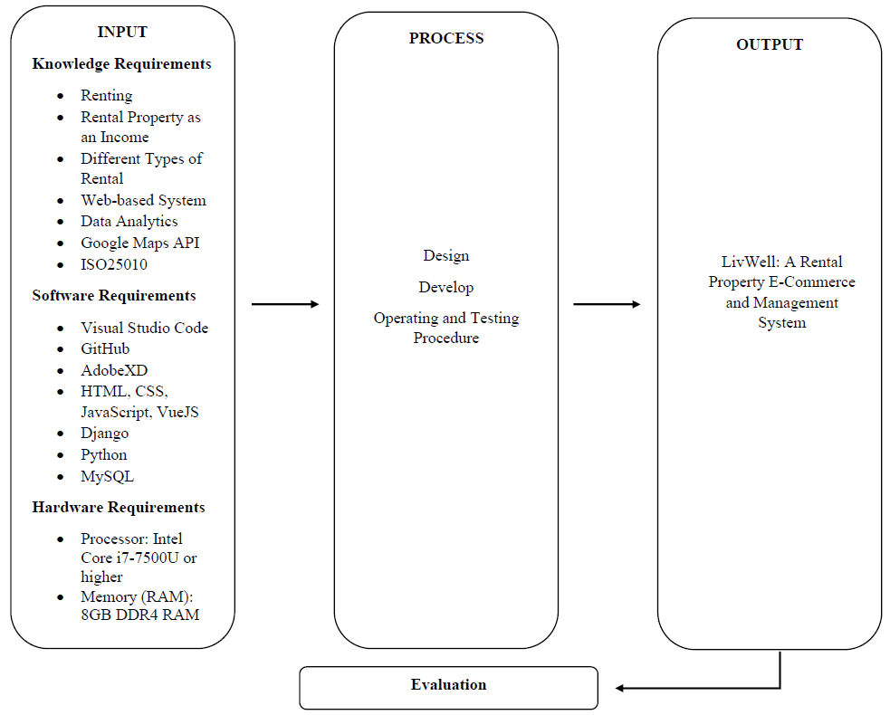

The figure above shows the study's conceptual model, which depicts the overview of the flow and the whole concept of the study.

**Input**

The content of the input phase is the three (3) major requirements of the system. First are the knowledge requirements under this requirement, the knowledge the researchers should understand to establish a foundation for the study. It consists of renting, rental property as an income, several types of rentals, web-based system, data analytics, Google Maps API, HTML, CSS, JavaScript, Vue.js, Django, Python, MySQL, and ISO25010. Second, the software requirements needed to develop the system. It consists of Visual Studio Code, GitHub, and Adobe XD. Lastly, the hardware requirements to access the system. It consists of a Processor: Intel Core i7-7500U or higher, and Memory (RAM): 8GB DDR4 RAM.

**Process**

The content of the process phase outlines how the system will be developed. This phase involves tasks such as designing, developing, operating, and testing procedures.

***Design***: In this phase, the researchers should create an entity relationship diagram, use case diagram, system flowchart, module hierarchy, data flow diagram, and architecture diagram. These diagrams help visualize and summarize the specifics of the system.

***Develop***: In this phase, the researchers will develop LivWell using front-end tools, back-end tools, frameworks, a database management system, version control, and an IDE.

***Operating and Testing Procedures***: After development, the system will undergo testing to assess its functionality.

**Output**

The developed system, LivWell: A Rental Property E-Commerce and Management System.

**Evaluation**

The developed system will be evaluated using ISO 25010, an assessment tool to examine the system's applicability, efficiency, compatibility, usability, dependability, security, maintainability, and portability.

## Operational Definition of Terms

For better understanding of the study, the researchers gave several terms that were defined operationally used in the study.

**LivWell** refers to the e-commerce and management system.

**Property Manager** refers to the house owner or landlord that oversees the property.

**Tenant** refers to the prospective individual that will rent a property for a while**.**

# Chapter 3 METHODOLOGY

This chapter contains the research methodology of the study with the following sections: project design, project development, operation and testing procedure, and evaluation procedure.

## Project Design

The study will develop a web-based system that will serve as a rental property e-commerce and management system. The web-based system is designed to assist tenants in finding listed properties for rent and help property owners list their properties and manage them. The project design of the study is explained below using the Entity Relationship Diagram, Use Case Diagram, System Flowchart, Module Hierarchy, Data Flow Diagram, and Wireframe.

***Entity Relationship Diagram***

The entity-relationship diagram (ERD) is a visual representation of the data model for a system. It depicts the system's entities, the attributes of those entities, and the relationships between them. In the context of a property e-commerce and management system, an ERD would illustrate entities such as Users, Listings, Properties, Tenants, Payments, and Notifications, showing how they interact and are related to each other. By using an ERD, people of interest can understand the data structure, identify potential issues, and ensure that the database is designed efficiently to support the system's functionality.

**Figure 2**

*Entity Relationship Diagram*

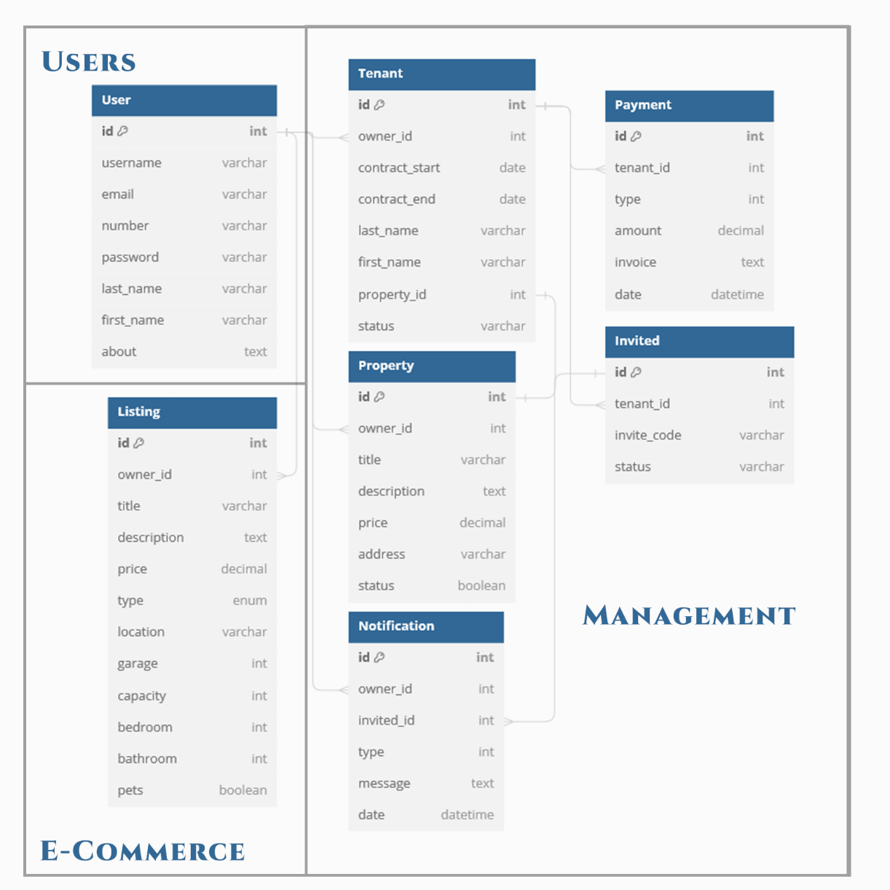

As the system revolves around properties, the main entities are the users, tenants, properties, and the listings. The relationship between the user and either the property or listings will be a one-to-many relationship since a user can list or manage multiple properties. This also includes the relationship between other entities such as the tenants to the property entity. A property can have multiple tenants associated with it over time. Other relationships are also present such as the notifications, payments, and the invite code which all aid in ensuring the system is working with all functionalities reached.

***Use Case Diagram***

The use case diagram is a visual representation of the functional requirements of a system, illustrating the interactions between users and the system itself. It displays the various ways a user can interact with the system to achieve specific goals. The purpose of a use case diagram is to provide a clear and organized depiction of the system's functional scope and the several ways users can utilize its features.

**Figure 3**

*Use Case Diagram*

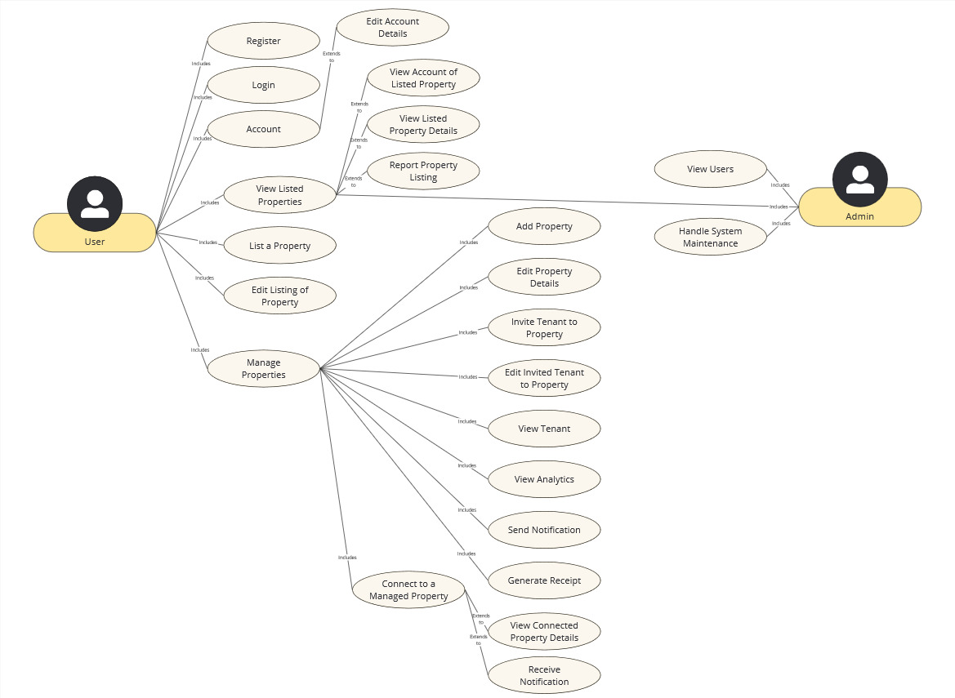

Each use case represents a distinct functionality or service provided by the system, highlighting the relationship between the actors and the use cases. In the context of a property e-commerce and management system, different functionalities can be done depending on the section in the system where the user is present.

The user has two main use cases, the e-commerce use case and the management use case. The e-commerce side of the system allows for viewing of property listings and the details of the property owner which one may contact for further inquiries, the user may also add property listings themselves to list properties.

The management side of the system on the other hand, has many functionalities that compose of managing the users’ properties. From listing property details, writing tenant information, checking for notifications or reminders, and the viewing of analytics. The option of joining a property through the invite tenant feature is also provided to allow for better transparency in tracking payments, and visibility in contacting the property owner.

***System Flowchart***

A system flowchart is a diagram that depicts the flow of data through a system and how different processes interact with each other. It is a visual representation that outlines the system’s steps, decision points, and the flow of control within. System flowcharts are used to understand, analyze, and communicate the structure and behavior of a system, making it easier to identify potential issues and optimize processes.

**Figure 4.A**

*System Flowchart (E-Commerce and Account Creation)*

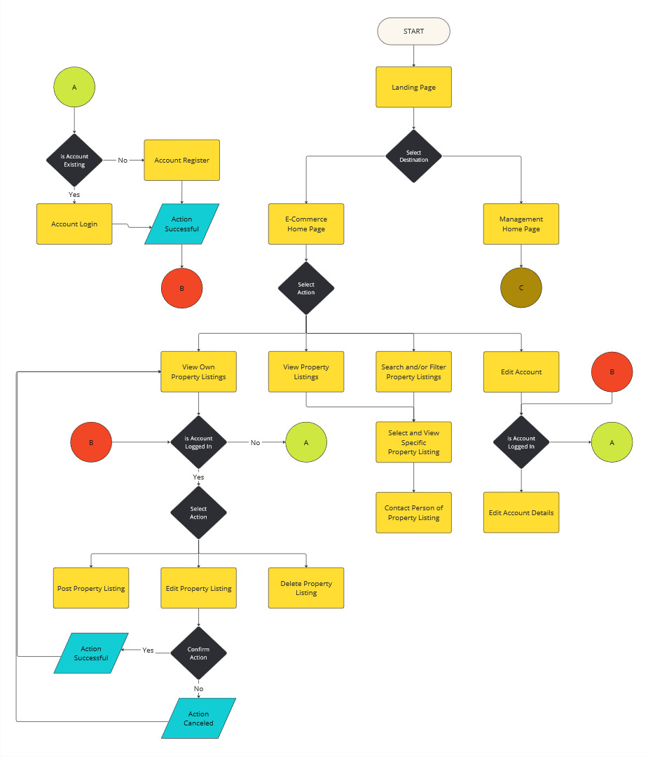

Shown in Figure 4.A is the flow of the system from the landing page, the functions of an account, to the e-commerce side of functionalities, ranging from posting to viewing property listings.

**Figure 4.B**

*System Flowchart (Management)*

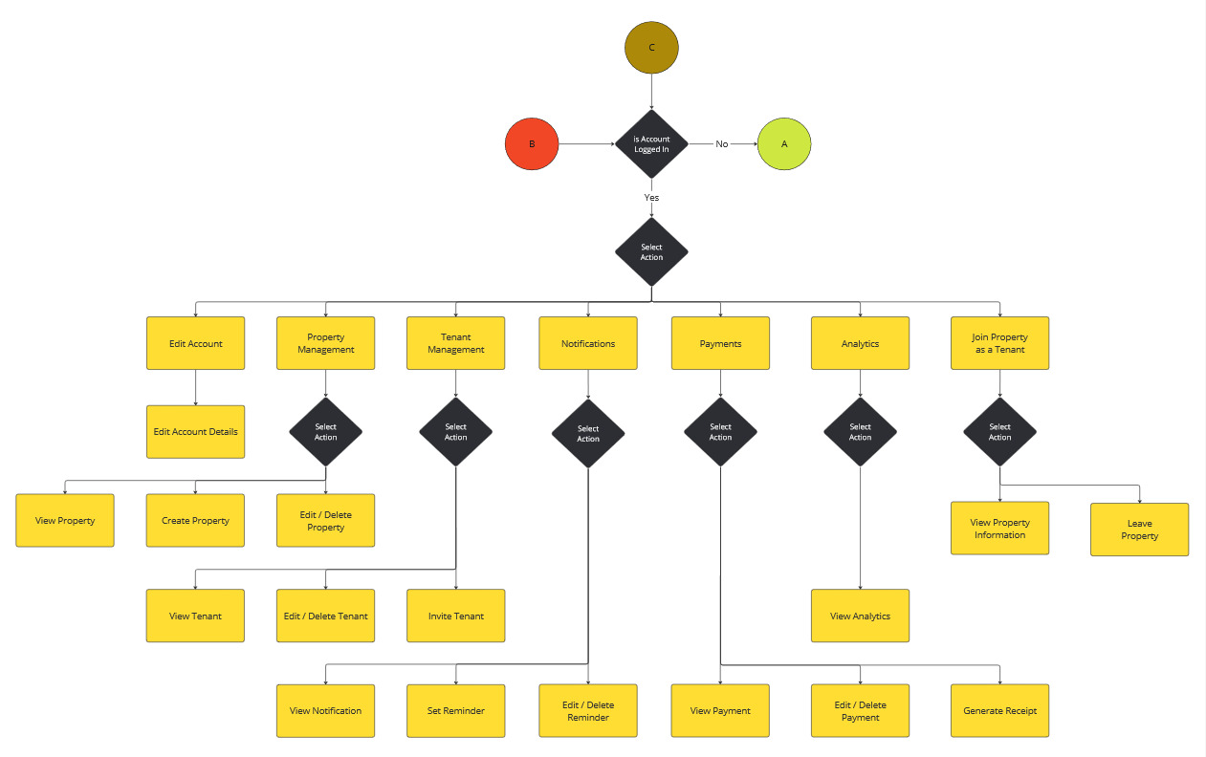

Shown in Figure 4.B is the flow of the system from the selection of the landing page to the management side of functionalities. Specific objectives such as the management of properties, tenants, notifications, payments, and analytics can be seen here. Also seen here is the joining of property as a tenant that will allow one to view the connected tenant information.

***Module Hierarchy***

A module hierarchy outlines the organization of different functional components in a software system, breaking down the application into manageable sections, each responsible for specific features or tasks.

**Figure 5**

*Module Hierarchy*

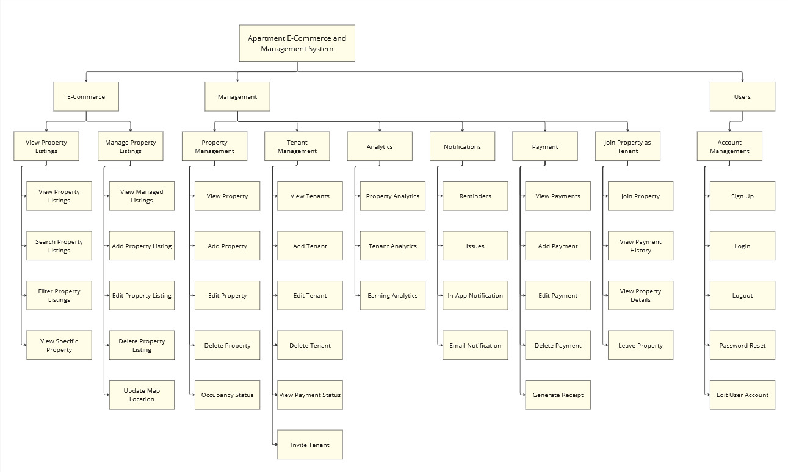 For the system’s module hierarchy, one can easily understand the functions of what each module can provide. The e-commerce module has the viewing and managing of property listings, with a search and filter for the viewing, and adding of map location for the managing. The management module has the different sub-modules that would aid the user in managing their properties and all that revolves around it. Included are the tenants, analytics, notifications, payments, and the invitation to join a tenant to your property. Lastly is the common module with the account feature that will be used in most of the sub-modules of the system contained in the e-commerce and the management systems.

***Data Flow Diagram***

A data flow diagram (DFD) is a graphical representation of the flow of data within a system. It illustrates how data is processed by a system in terms of inputs and outputs, and how it moves between different entities, processes, and data stores. DFDs help in understanding the overall functionality of the system and the interactions between its components.

A Context Diagram is the highest level in a Data Flow Diagram and provides a broad overview of the system. It depicts the system as a single process and shows its interaction with external entities. The context diagram helps in understanding the system boundaries and the main data exchanges with the external environment.

**Figure 6**

*Data Flow Diagram – Level 0 (Context Diagram)*

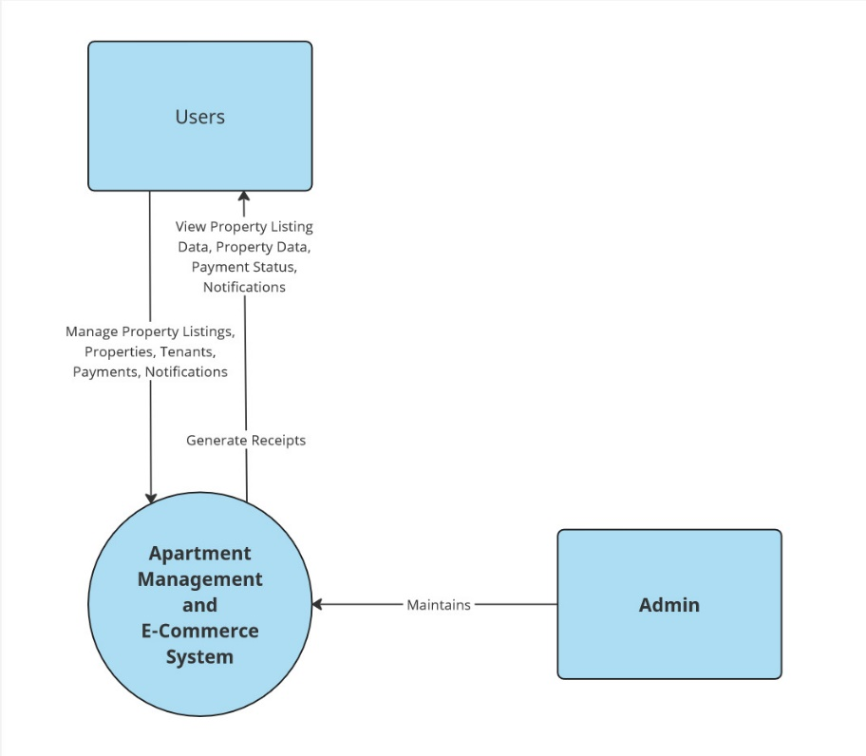

**Figure 7**

*Data Flow Diagram – Level 1*

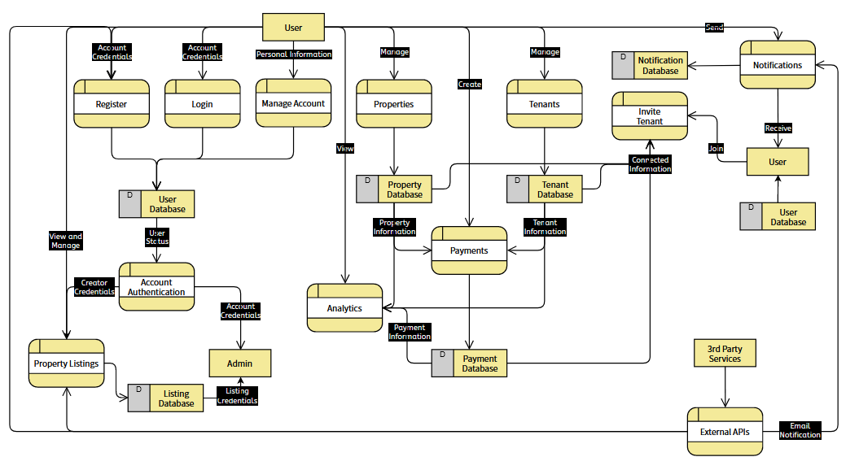

***Wireframe***

**Figure 8**

*Home Screen Page*

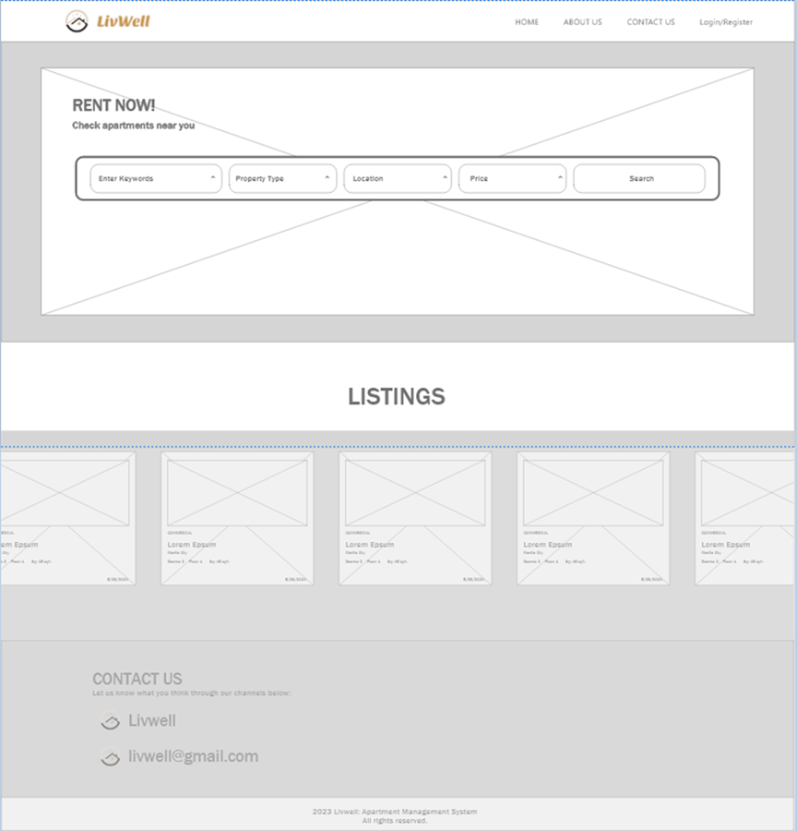

Figure 8 shows the home screen, including a navbar in the top right and a logo on the top left. The 'Login/Register' feature is where users can log in and register. The first part of the dashboard features keywords, property types, and price filters that users can use to find an apartment. After scrolling down, in the 'Listing' section, it shows several types of properties. Before the footer, it displays the website's email account.

**Figure 9**

*About Us Page*

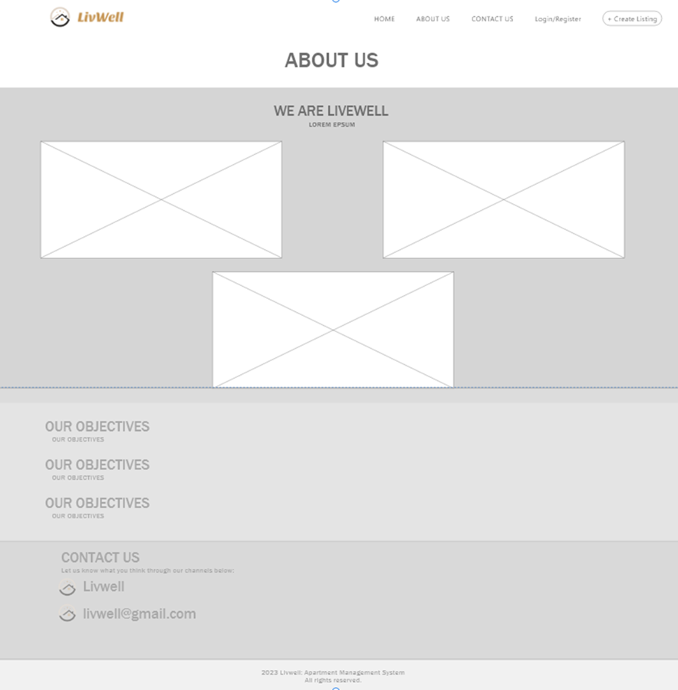

Figure 9 shows the about us page. It features what the website is all about and the objectives of the website.

**Figure 10**

*Register*

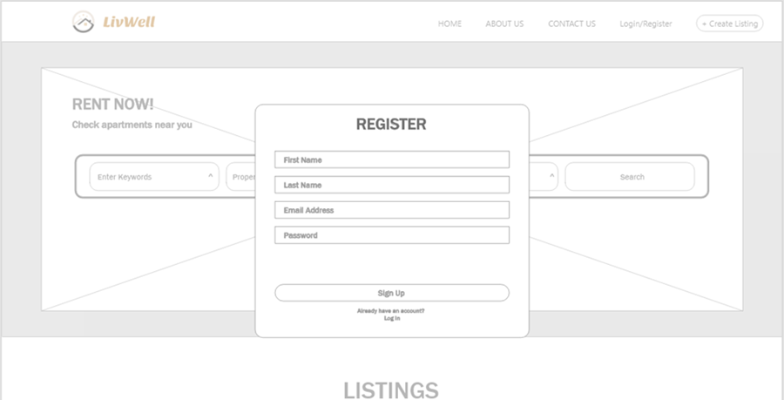

Figure 10 shows the register modal. It shows where the user can register to create an account.

**Figure 11**

*Login*

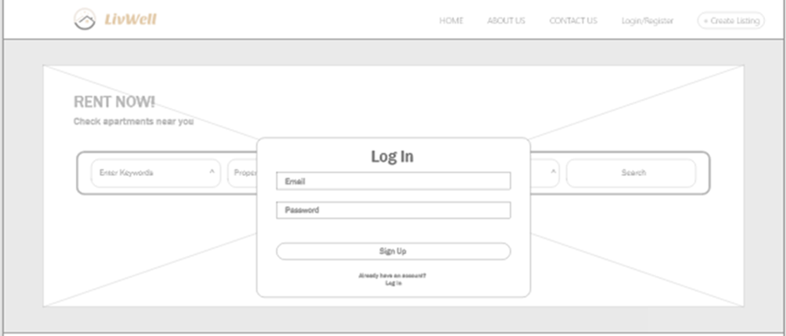

Figure 11 shows the login modal, where the user can log in to his/her account.

**Figure 12**

*Landing Page*

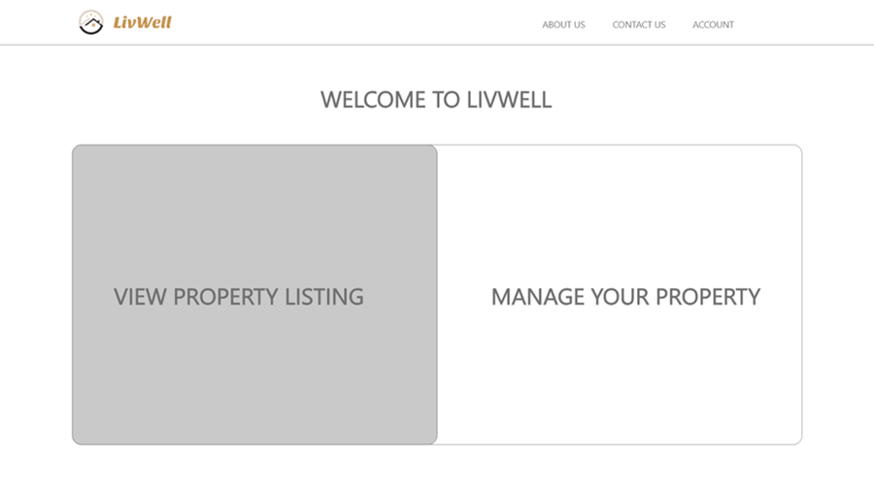

Figure 12 shows the landing page that can be seen after logging in, clicking the logo on the top left will navigate the user to a view where they can choose between 'Property Listing' or 'Manage Your Property'.

**Figure 13**

*Property Listing Page*

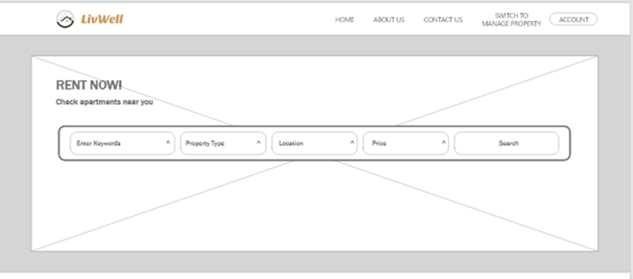

Figure 13 shows the property listing page that will be seen after choosing 'Property Listing' on the landing page. The page will feature a search bar. There will also be a button in the navbar to switch to 'Manage Property'.

**Figure 14**

*View Property Page*

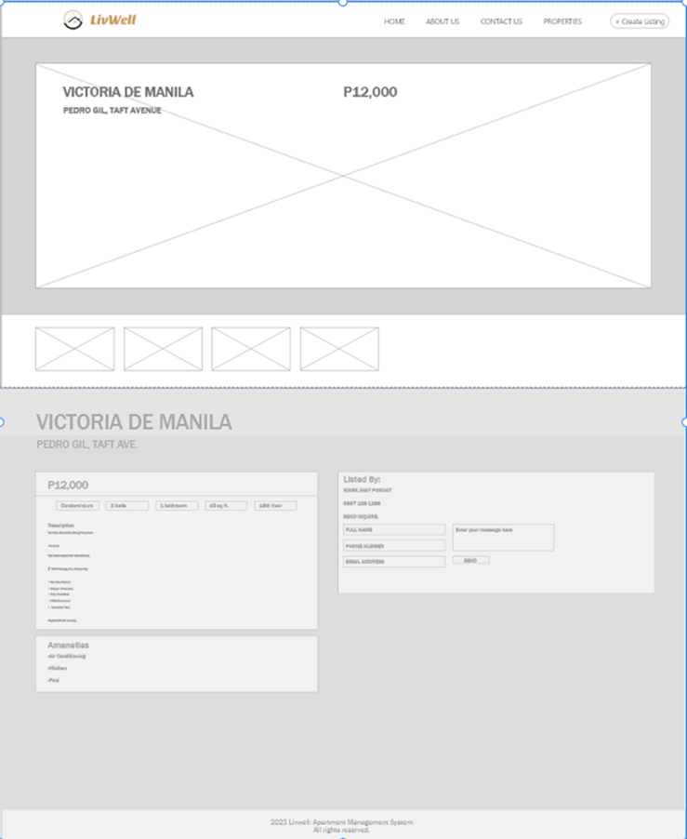

Figure 14 shows the view property page. After the user clicks on a property, it will display information such as price, location, amenities, and the size of the property. The user can also click the 'Send' button on the left side of the information section. After writing a message to the landlord, this will connect the interested user with the landlord.

**Figure 15**

*Adding Property Listing Page*

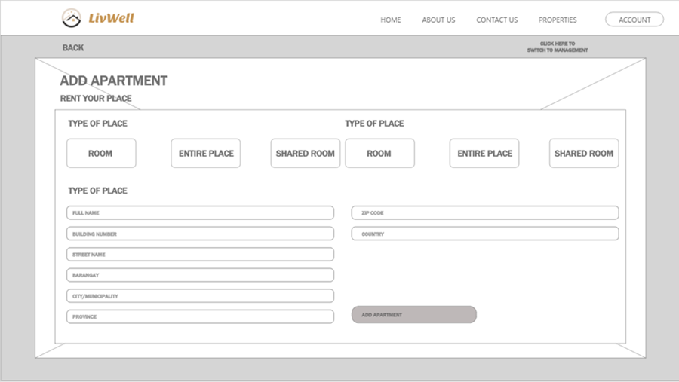

Figure 15 shows the adding property listing page after clicking the ‘Create Listing’. In this property page, the landlord can add an apartment to their account.

**Figure 16**

*Management Property Page*

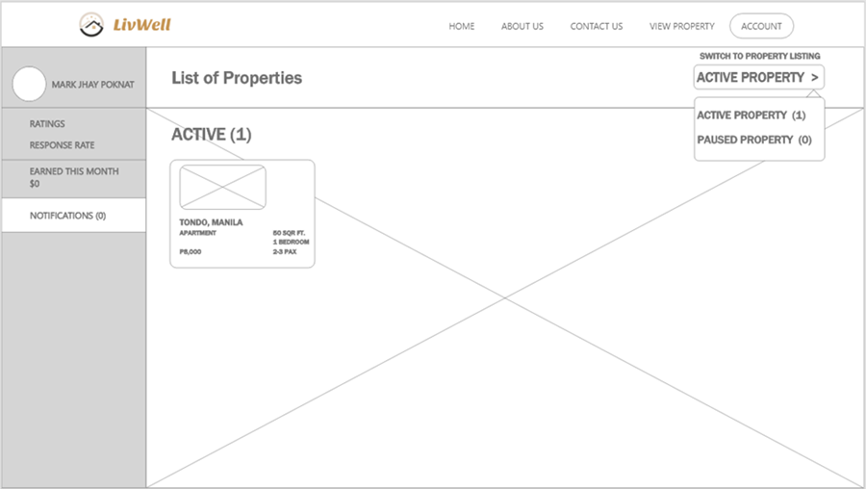

Figure 16 shows the management property page. After clicking 'Manage Your Property' on the landing page, it will feature a list of properties. The dashboard will show the active properties.

**Figure 17**

*Notification*

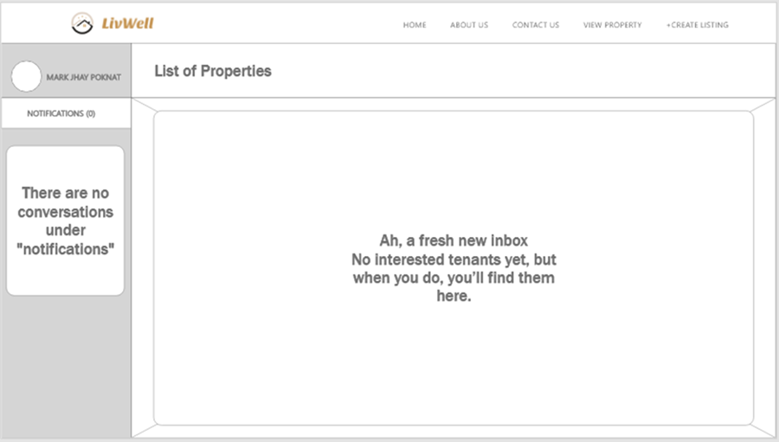

Figure 17 shows notification. This is the point of view of the landlord if there are interested tenants in his/her apartment. After the interested tenant clicks the 'Send' button in Figure 14, it will notify the landlord that there are tenants who want to inquire.

**Figure 18**

*Analytics*

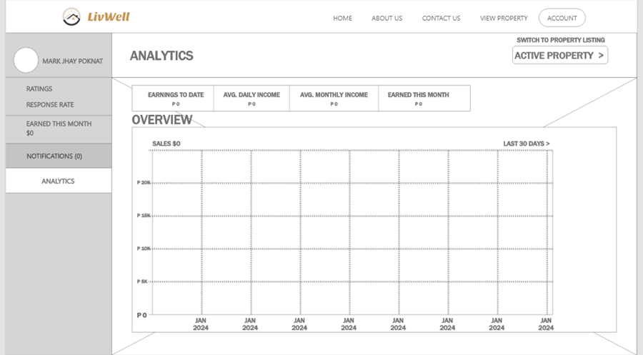

Figure 18 shows the analytics page. It features an overview of the landlord's sales, showing how much the landlord earns.

**Figure 19**

*Tenant Information Page*

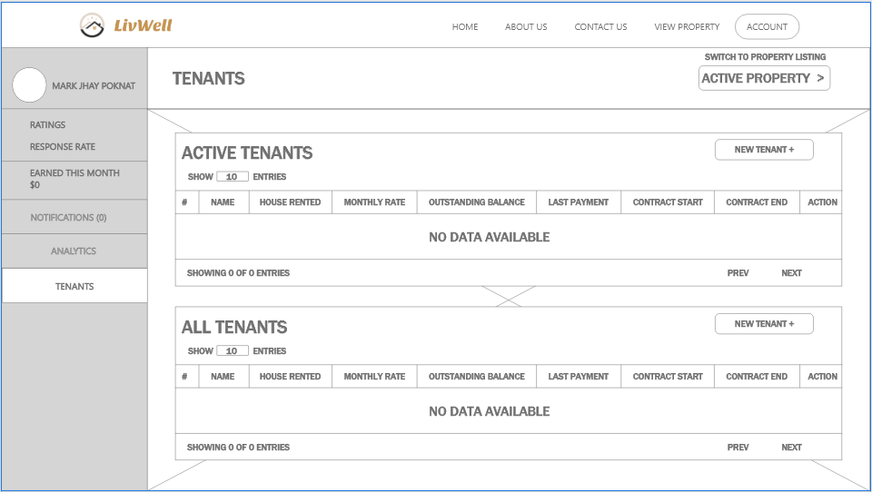

Figure 19 shows the tenant information page, where it shows the data of all tenants such as name, payment, and contract.

**Figure 20**

*Payment Page*

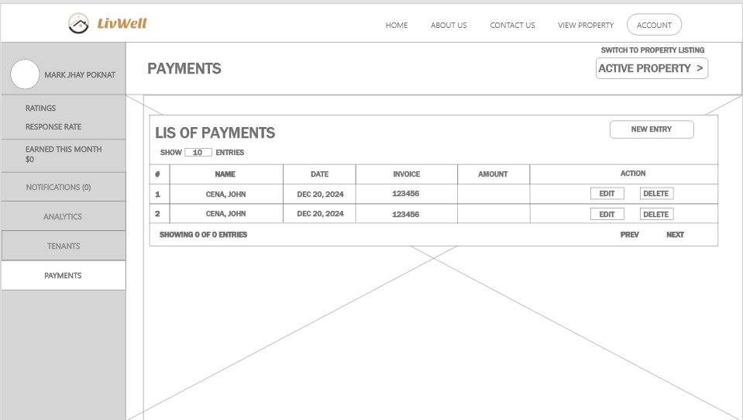

Figure 20 shows the payment page, it features the payments of the tenants; it tracks down the payments of each tenant.

**Figure 21**

*Profile Information Page*

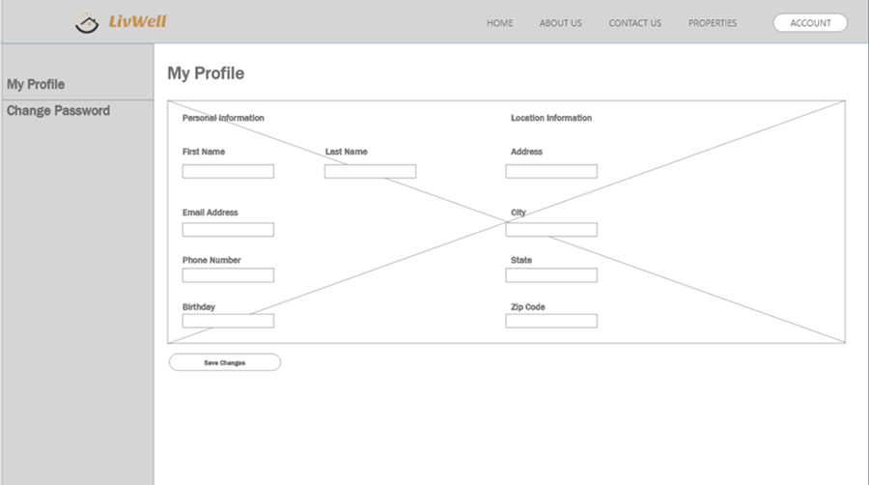

Figure 21 shows the profile information page. After clicking the ‘Account’ in the right side of the navbar, it will show the profile information section and the user can edit the information.

**Figure 22**

*Password Section Page*

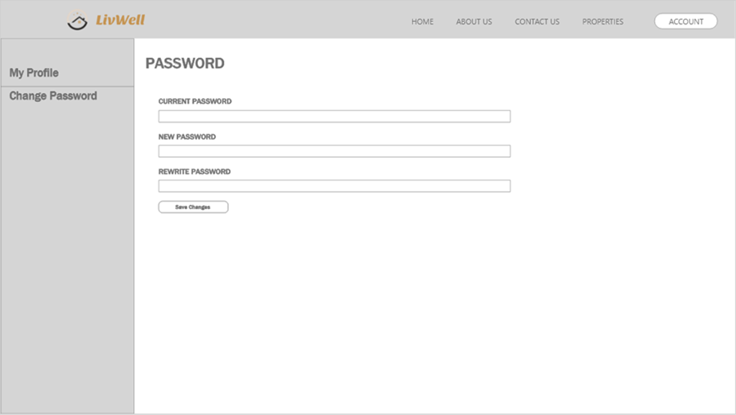

Figure 22 shows the password section page, it features fields for the current password, new password, and confirmation of the new password. The user can change their password anytime they want to.

## Project Development

**Figure 23**

*Agile Scrum Methodology Framework*

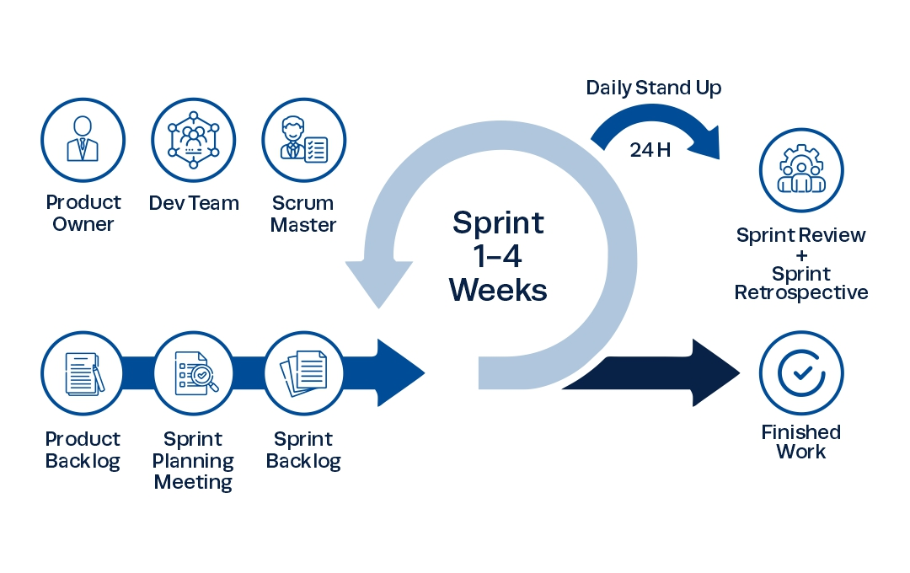 The methodology the researchers will use in developing the E-Commerce and Management System is Agile Scrum Methodology. According to Peek (2023), agile scrum methodology is a project management system that relies on incremental development. The researchers decided to use this methodology as it is the most befitting methodology considering the timeline and general ability of the researchers. Additionally, it will allow the researchers to work on projects in small increments, which results in easily identifying the problems the researcher will encounter.

***Phases:***

* **Sprint Planning Meeting.** In this phase, the researchers will meet to discuss the module from the product backlog that they will work on in the next sprint and the timeline for doing so.
* **Daily Scrum Meeting.** In this phase, the researchers will hold a meeting to monitor and evaluate the project’s status and ensure that everyone is working on their assigned tasks.
* **Sprint Review.** This phase is conducted at the end of every sprint. In this phase, the researchers will present their finished work to their capstone adviser. The adviser will then review the work and decide whether any changes are needed or if the work is acceptable.
* **Sprint Retrospective.** In this phase, the researchers will hold a meeting to discuss what went well during the last sprint and what can be improved in the next one. This meeting will result in continuous improvements, making each sprint more successful than the last.

***Roles:***

* **Product Owner.** An individual or business who will utilize the software. They are the ones who determine which features and modules will be included in the product, what changeswill be made, and whether to accept or reject the completed product.
* **Development Team.** The researchers who are responsible for delivering the committed product increments.
* **Scrum Master.** An individual responsible for the productivity and effectiveness of the development team. They ensure that the team comprehends scrum principles, theoretically and practically, providing aid and guidance as the team advances through their sprints.

***Tools:***

* **Product Backlog.** This tool comprises a comprehensive list of features and modules derived from the needs and requirements to develop LivWell: A Rental Property E-Commerce and Management System.
* **Sprint Backlog.** This tool is the tasks selected from the product backlog during the Sprint Planning Meeting phase that need to be accomplished in the upcoming sprint.

## Operating and Testing Procedure

To guarantee that the system works properly, its features and capabilities were thoroughly tested. The testing method validates each function in the system if it is working and performing as planned.

**Functional Suitability Testing** will be performed to examine the functionality of the web application’s features to ensure that it is functioning based on the intended results. The test cases contain a set of inputs, execution precondition, and expected outcomes. The form for test cases will be utilized, as shown in Table 1.

**Table 1**

*Sample Test Case*

|  |  |  |  |  |  |  |
| --- | --- | --- | --- | --- | --- | --- |
| **Test Case ID** | |  | | **UC Reference** |  | |
| **Objective** | |  | | | | |
| **Assumptions/ Preconditions** | |  | | | | |
| **Actions** | | **Expected Result** | | **Actual Result** | | |
|  | |  | |  | | |
| **Status** |  | **Severity** | **MAJOR** | **Priority** | | **HIGH** |

The table is a template of the test case form used by the researchers. Each row represents a test case with details such as the test case ID, objective, expected result, action procedure, test data, expected result, and actual result. The status column indicates whether the test case passed, failed, was not executed, or was blocked. This structured format ensures thorough testing and validation of the web application's functionality.

**Table 2**

*Classification of Error Severity*

|  |  |
| --- | --- |
| **Severity** | **Description** |
| Critical | The problem signifies that the process has been completely stopped and cannot continue until it is resolved. |
| Major | The problem causes the system to crash. Nevertheless, some system components are still functional. |
| Minor | The problem does not result in any significant system failure. |

The table offers a detailed classification of error severity levels, including Critical, Major, and Minor categories. This structured approach serves as a quick reference guide for assessing the impact and severity of faults within a system. By categorizing errors into these severity levels, stakeholders can efficiently prioritize and allocate resources to address issues effectively, ensuring timely resolution of critical problems and efficient management of less severe issues.

**Table 3**

*Classification of Error Priority Levels*

|  |  |
| --- | --- |
| **Priority** | **Description** |
| High | The problem needs to be resolved as soon as possible since it significantly affects the application. |
| Medium | The problem should be fixed throughout the normal course of development. |
| Low | The problem must be resolved when a more crucial feature is taken care of. |

The table categorizes error priority levels into High, Medium, and Low, along with detailed descriptions for each. This structured approach helps in prioritizing and allocating resources to address and resolve issues based on their impact and urgency. By assigning the appropriate priority level to each error, development teams can efficiently manage their workflow, ensuring that critical issues are fixed promptly while less critical problems are addressed at the right time during the development cycle.

**Table 4**

*Overall Summary of Functionality Test Cases*

|  |  |
| --- | --- |
| **Use Case** | **No. Of Test Cases** |
| Unregistered User |  |
| Verified User |  |
| **Total** |  |

The table categorizes test cases based on user roles, including "Unregistered User," and "Verified User,". The "Total" row aggregates the total number of test cases across all user roles. This structured format serves as a template for capturing and organizing test case information, ensuring comprehensive coverage of functionality for each user type.

**Table 5**

*Reliability Test Cases Summary*

|  |  |
| --- | --- |
| **Test Case ID** | **Objectives** |
|  |  |

The test case ID is a unique identifier assigned to each test case, allowing for easy reference and tracking. Each test case's objectives include a detailed description of the goals and purposes, specifically outlining the aspects of reliability being tested or verified.

**Table 6**

*Testing Procedure for Functionality Suitability*

|  |  |  |
| --- | --- | --- |
| **Module** | **Steps to be undertaken** | **Expected Result** |
| 1. Sign up | 1. From the home page, click sign-up 2. Enter user details 3. Click sign-up | 1. Incomplete input from the user will be handled by the application with error message displayed. |
| 1. Login | 1. From the home page, click login. 2. Enter existing user details. 3. Click login | 1. The user will be redirected to the home screen with correct details. 2. Error message will be displayed if the user entered wrong details |
| 1. Property Listings | 1. From the landing page, click view property listing. 2. You can search for property by entering the details needed. | 1. The user will be able to view the filtered properties listed. 2. The user can click the property. 3. The user will be able to see the information about the property listed. |
| 1. Manage Property Listing | 1. From the landing page, click view property listing. 2. Click create listing at the navigation bar. 3. Input details about the property for rent. 4. Click the add apartment button. | 1. The property will be added to the property listing. |
| 1. Property Management | 1. From the landing page, click manage your property. | 1. The user will be able to see the management dashboard. |
| 1. Tenant Management | 1. From the side bar, click tenant management. 2. Add, view, delete, and update tenant’s information. | 1. The user will be able to view a table about the tenant’s information. |
| 1. Analytics | 1. From the side bar, click analytics. | 1. The user will be able to view analytics. |
| 1. Payment | 1. From the side bar, click payment. 2. Add, view, delete, and update payments. 3. Generate a receipt. | 1. The user will be able to download the receipt. 2. The user will be able to view a table about the payments of the tenants. |

Reliability Testing will be conducted to evaluate the system's performance under specific environmental conditions and over a specified period. The table above will be used to document and organize test cases for various system modules and functionalities, including sign up, log in, property listings management, property management, tenant management, report, and payment. This structured approach ensures that each capability is thoroughly tested and validated against expected outcomes.

**Table 7**

*Testing Execution Summary*

|  |  |  |  |
| --- | --- | --- | --- |
| **Test Execution** | **Expected Result** | **Active Result Cycle 1** | **Cycle 2** |
| No. of Test Cases Executed | 100% |  |  |
| Results of Test Cases |  |  |  |
| Passed | 100% |  |  |
| Failed | 0% |  |  |
| No. of Test Cases Not Executed | 0% |  |  |

The table provides a summary of the test execution, indicating that all test cases have been completed with no remaining unexecuted tests. The expected results column is currently blank and requires filling in with the anticipated outcomes for each test case. The results of the tests conducted show that all test cases passed without any failures. This table serves as a status overview, confirming that the testing was successful and complete.

## Evaluation Procedure of the Study

In assessing the system, ISO 25010 will be utilized to evaluate software product quality. The prototype will be reviewed by a diverse group of evaluators, including students, faculty members, professional workers, property owners, and potential tenants. Participants from the College of Science, consisting of faculty and students, will also be involved in the evaluation. The evaluation will include at least 30 respondents to ensure a comprehensive assessment of the prototype’s performance and quality. During the system demonstration, audience members will be provided with surveys to complete. The evaluation procedure is presented as follows:

**General Evaluation Process**

1. Each respondent will receive a software assessment form to evaluate the effectiveness of the system.
2. The web-based application's functions will be demonstrated, and a discussion of its objectives will be held to demonstrate how to use it.
3. The system will be made available to all respondents.
4. According to Table eight (8), which uses a four-point Likert scale, where four (4) is the highest rating and one (1) is the lowest rating, the respondents will be asked to evaluate the system considering the ISO 25010 standard evaluation criteria.
5. This project will be evaluated using the following characteristics: functional suitability and reliability.
6. The overall weighted mean rating for each criterion and the grand weighted mean will be determined based on the evaluation data to be collected.
7. The evaluation outcome will be made use of the weighted mean value range shown in table nine (9) and the qualitative analysis relating to that range.

**Table 8**

*Four-point Likert Scale*

|  |  |
| --- | --- |
| **Scale** | **Descriptive Rating** |
| 4 | Highly Acceptable |
| 3 | Very Acceptable |
| 2 | Fairly Acceptable |
| 1 | Not Acceptable |

The table above presents a scale with numerical values and descriptive ratings ranging from 1 to 4. On this scale, 4 indicates "Highly Acceptable," 3 indicates "Very Acceptable," 2 indicates "Fairly Acceptable," and 1 indicates "Not Acceptable." This scale is used to evaluate the level of acceptability of various items or criteria, with higher numerical values representing more favorable ratings. The descriptive ratings provide qualitative insight into the corresponding numerical values, aiding in the identification and analysis of acceptability.

**Table 9**

*The Range of Mean Ratings and the Equivalent Descriptive Rating*

|  |  |
| --- | --- |
| **Scale** | **Descriptive Rating** |
| 3.26 - 4.00 | Highly Acceptable |
| 2.51 - 3.25 | Very Acceptable |
| 1.76 - 2.50 | Fairly Acceptable |
| 1.00 - 1.75 | Not Acceptable |

Each row in the table above represents a numerical range, and the corresponding column provides a descriptive rating. This scale is used to assess or grade something based on its level of acceptability, with each rating associated with a specific numerical range. For example, a value between 3.26 and 4.0 is classified as "Highly Acceptable." Similarly, values within other ranges are labeled as "Very Acceptable," "Fairly Acceptable," or "Not Acceptable," according to the specified descriptors.

## REFERENCES

Adetunji, H. (2023, December 28). What is HTML: A detailed explanation of the programming language. *Medium*. <https://medium.com/@hikmohadetunji/what-is-html-a-detailed-explanation-of-the-programming-language-1d0ab69f475d>

Başarsoft Bilgi Teknolojileri A.Ş. (2023, January 31). *What is Google Maps Platform? | Başarsoft*. Başarsoft. <https://www.basarsoft.com.tr/en/google-maps-platform-api/>

BasuMallick, C. (2022, November 7). *CSS Guide: How it Works and 20 Key Properties - Spiceworks Inc*. Spiceworks Inc. <https://www.spiceworks.com/tech/tech-general/articles/what-are-css/>

Britton, J. (2021, May 6). *What is ISO 25010?* Perforce Software. <https://www.perforce.com/blog/qac/what-is-iso-25010>

Buenning, M. (2024, February 2). What is MySQL & How does it work?. NinjaOne. <https://www.ninjaone.com/it-hub/endpoint-management/what-is-mysql-how-does-it-work/>

Caltabanis, G. (2023, October 12). *What is Rental Property - Definition of Rental Property | Verdant*. Verdant®. <https://verdant.copeland.com/glossary/rental-property/>

Chris, K. (2023, February 3). *Visual Studio vs Visual Studio Code – What's The Difference Between These IDE Code Editors?* freeCodeCamp.org. <https://www.freecodecamp.org/news/visual-studio-vs-visual-studio-code/>

Corbo, A. (2022, December 29). *What is vue JS?* Built In. <https://builtin.com/software-engineering-perspectives/vue-js>

Coursera. (2023, November 29). *What is GitHub and why should you use it?* Coursera. <https://www.coursera.org/articles/what-is-git>

Coursera. (2024, April 3). *What is Python used for? A beginner’s guide*. Coursera. <https://www.coursera.org/articles/what-is-python-used-for-a-beginners-guide-to-using-python>

*Customer stories*. (2024). GitHub. <https://github.com/customer-stories>

*Django introduction - Learn web development | MDN*. (2024, February 28). MDN Web Docs. <https://developer.mozilla.org/en-US/docs/Learn/Server-side/Django/Introduction>

Eygi, C. (2021, December 9). CSS for Beginners: What is CSS and How to Use it in Web Development? *Medium*. <https://medium.com/swlh/css-for-beginners-what-is-css-and-how-to-use-it-in-web-development-5985afe53096>

Fishman, S. (2019, December 30). *Is your rental activity a business or an investment?* www.nolo.com. <https://www.nolo.com/legal-encyclopedia/is-your-rental-activity-business-investment.html>

G, D. (2024, January 19). *What is MySQL and how does it* *work*. Hostinger Tutorials. <https://www.hostinger.ph/tutorials/what-is-mysql>

G, D. (2023, May 15). *What is CSS and how does it work?* Hostinger Tutorials. <https://www.hostinger.ph/tutorials/what-is-css>

GeeksforGeeks. (2024, February 2). *Introduction to JavaScript*. GeeksforGeeks. <https://www.geeksforgeeks.org/introduction-to-javascript/>

GeeksforGeeks. (2024, April 18). *Django Tutorial Learn Django Framework*. GeeksforGeeks. <https://www.geeksforgeeks.org/django-tutorial/>

Ghasemaghaei, M. (2019). Does data analytics use improve firm decision making quality? The role of knowledge sharing and data analytics competency. Decision Support Systems, 120, 14–24. <https://doi.org/10.1016/j.dss.2019.03.004>

Hamzah, Muhammad Akram, Mustika, Nur , Mustapa, Mahmud, Rahmah, Ummiati

(2022). Application of Boarding House Rental Location Search System

Based on Android from

[http://eprints.unm.ac.id/32270/1/Hamzah_2022_Ceddi_Application%20of%20Barding%20House%20Rental%20Location%20Search%20System%20Based%20on%20Android%20.pdf](http://eprints.unm.ac.id/32270/1/Hamzah_2022_Ceddi_Application%20of%20Boarding%20House%20Rental%20Location%20Search%20System%20Based%20on%20Android%20.pdf)

Heller, M. (2022, July 8). *What is Visual Studio Code? Microsoft’s extensible code editor*. InfoWorld. <https://www.infoworld.com/article/3666488/what-is-visual-studio-code-microsofts-extensible-code-editor.html>

Ikuomola, A. J., & Asefon, M. P. (2020). A secured mobile cloud-based house rental management system. In *Proceedings of 3rd International Conference on Applied Information Technology (AIT)* (pp. 1-17). <https://www.researchgate.net/publication/340926278_A_Secured_Mobile_Cloud-Based_House_Rental_Management_System>

*ISO 25010*. (n.d.). <https://iso25000.com/index.php/en/iso-25000-standards/iso-25010?start=5>

Iu, C. S., & Mohd Zaki Mohd Salikon. (2022). Room Renting Management System. *Applied Information Technology* *And Computer Science*, *3*(2), 1451–1469. <https://publisher.uthm.edu.my/periodicals/index.php/aitcs/article/view/7471>

Jordana, A. (2024, May 13). *What Is JavaScript: A Beginner’s Guide to the Basics of JS*. Hostinger Tutorials. <https://www.hostinger.ph/tutorials/what-is-javascript>

Juviler, J. (2022, September 14). *Google Maps Platform*. <https://blog.hubspot.com/website/google-maps-api>

Khan, F.& Scholtz, L.(2011)*.* Rental housing. <https://www.researchgate.net/publication/236974439_Rental_Housing>

Kugell, A. (2022, April 24). In-Depth look at VueJs: pros, cons, and real-life applications in 2024 - Trio. *Trio*. <https://trio.dev/why-use-vue-js/>

Lukaszewski, A. (2019, July 3). *What is Python programming Language?* ThoughtCo. <https://www.thoughtco.com/what-is-python-2813564>

Lutkevich, B. (2020, February 17). *HTML (Hypertext Markup Language)*. TheServerSide.com. <https://www.theserverside.com/definition/HTML-Hypertext-Markup-Language>

Lutkevich, B., & Courtemanche, M. (2023, February 21). *GitHub*. IT Operations. <https://www.techtarget.com/searchitoperations/definition/GitHub>

Majaski, C. (2024, February 13). *Renting vs. Owning a Home:* *What's the Difference?* Investopedia. <https://www.investopedia.com/articles/personal-finance/083115/renting-vs-owning-home-pros-and-cons.asp>

Mansa, Julius. (2023, July 16). How Does Supply and Demand Affect the Housing Market?

*Investopedia*.   
<https://www.investopedia.com/ask/answers/040215/how-does-law-supply-and-demand-affect-housing-market.asp>

Megida, D. (2021, April 28). *What is JavaScript? A Definition of the JS Programming Language*. freeCodeCamp.org. <https://www.freecodecamp.org/news/what-is-javascript-definition-of-js/>

Merriam-Webster. (n.d.). Renting. In Merriam-Webster.com thesaurus. <https://www.merriam-webster.com/thesaurus/renting>

Miller, S. (2023, May 4). *What is Python Used For?* Codecademy Blog. <https://www.codecademy.com/resources/blog/what-is-python-used-for/>

Misyam, M. R., & Selamat, N. (2021, November 30). House Rental Management System. Applied Information Technology And Computer Science, 2(2), 1745P-1754.<https://publisher.uthm.edu.my/periodicals/index.php/aitcs/article/view/2488>

Monteverde, A. L., Maderazo, J. J. S., Cruz, K. C. M., & Magnaye, N. A. (2023). A web-based rental house smart finder using rapid application development basis for evaluation of ISO 205010. *International Journal of Metaverse* (IJM), 1(1), 1-12.<https://doi.org/10.54536/ijm.v1i1.1464>

Mokhsin, M., Shahuddin, A. Z., Zainol, A. S., Som, M. H. M., & Hazemi, N. B. (2020). A prototype of high rise residential management systems in Malaysia: A case study for Seroja Apartment. IJIES (International Journal of Innovation in Enterprise System), 4(01), 1–11. from <https://doi.org/10.25124/ijies.v4i01.43>

Muñoz-Villamizar, A., Solano-Charris, E. L., Azad, M., & Reyes-Rubiano, L. S. (2021). Study of urban-traffic congestion based on Google Maps API: the case of Boston. IFAC-PapersOnLine, 54(1), 211–216. <https://doi.org/10.1016/j.ifacol.2021.08.079>

Myre, M. (2022, July 26). The UX Designer’s Guide to Adobe XD | DesignLab. *Designlab*. <https://designlab.com/blog/ux-designer-guide-to-adobe-xd>

Noble Desktop. (2024, May 15). *What is Django and How is it* *used?*. <https://www.nobledesktop.com/classes-near-me/blog/what-is-django>

Obrenović, B. Ž. (2021, October 21). ISO 25010 Standard. *Grounded Architecture: Redefining IT Architecture Practice*. <https://grounded-architecture.io/concepts-iso25010>

Paul, J. (2022). The Rental Zone (House Renting Website). International Research Journal of Modernization in Engineering Technology and Science, 4(8), 2243-2248. <https://www.irjmets.com/uploadedfiles/paper/issue_8_august_2022/29592/final/fin_irjmets1662125360.pdf>

Peek, S. (2023, November 13). What is Agile scrum methodology?

<https://www.businessnewsdaily.com/4987-what-is-agile-scrum-methodology.html>

Rastogi, R., Jain, R., Mishra, P., & Prateek. (2023). Rental House Management System: An Empirical Approach with Simulation. *Acta Scientific COMPUTER SCIENCES*, *5*(4). <https://actascientific.com/ASCS/pdf/ASCS-05-0434.pdf>

Rathod, Ashish , Kumar, Pawan (2022). Apartment Management System: a review. IJRASET. <https://www.ijraset.com/research-paper/apartment-management-system>

Rathore, K., Syed, A., & Patel, R. (2021). Rental house management system. *International Research Journal of Modernization in Engineering Technology and Science*, 3(5), [1098]. <https://www.irjmets.com/uploadedfiles/paper/volume3/issue_5_may_2021/10054/1628083403.pdf>

S, A. (2023, August 25). *What is HTML? Hypertext Markup Language Basics explained*. Hostinger Tutorials. <https://www.hostinger.ph/tutorials/what-is-html>

Santander, B. (n.d.). *Renting*. Banco Santander. <https://www.bancosantander.es/en/glosario/renting>

Senthil.k-Wp. (2024, March 13). *The Benefits of Web-Based Systems for Business - Aezion*. Aezion. <https://www.aezion.com/blogs/the-benefits-of-web-based-systems-for-business/>

Setty, Y. (2020) Management System for an Apartment. Opus Open Portal to University Scholarship. <https://opus.govst.edu/cgi/viewcontent.cgi?article=1542&context=capstones>

Shao, C., Yang, Y., Juneja, S., & GSeetharam, T. (2022). IoT data visualization for business intelligence in corporate finance. Information Processing and Management, 59(1), 102736. from <https://doi.org/10.1016/j.ipm.2021.102736>

Simplilearn. (2022, September 22). *The Best Guide to Know What is Vue JS*. Simplilearn.com. <https://www.simplilearn.com/tutorials/java-tutorial/what-is-vue-js>

Statista. (n.d.). Residential Real estate Leases - Philippines | Forecast.

<https://www.statista.com/outlook/fmo/real-estate/residential-real-estate/residential-real-estate-leases/philippines#analyst-opinion>

Thevaraju, Devi Priya, Zakaria, Zalmiyah, Sukrib, Khairul Amin Mohamad, Kasimb, Shahreen (2019) View of Vista Angkasa Apartment Management System. <https://ijasce.org/index.php/IJASCE/article/view/4/61?fbclid=IwAR2LnvMNJxKLtHIpPyXaj0W0-Av_O7sXrcHnBdI9MluY1ubpHrouuaOXBlM>

The Investopedia Team. (2024, April 23). Data Analytics: What It Is, How It's Used, and 4 Basic Techniques. Investopedia. <https://www.investopedia.com/terms/d/data-analytics.asp>

*The many types of rental properties | arrived*. (2022, September 14). Arrived. <https://arrived.com/blog/the-many-types-of-rental-properties>

*Visual Studio vs Visual Studio Code - What’s Best In 2024?* (n.d.). <https://www.turing.com/kb/ultimate-guide-visual-studio-vs-visual-studio-code>

Voumick, D. , Deb, P. , Sutradhar, S. and Khan, M. (2021) Development of Online Based Smart House Renting Web Application. *Journal of Software Engineering and Applications*, **14**, 312-328. doi: [10.4236/jsea.2021.147019](https://doi.org/10.4236/jsea.2021.147019)

Wallen, J. (2021, August 23). *What is MySQL?* Lifewire. <https://www.lifewire.com/what-is-mysql-4582965>

Webb, M. (2024, February 19). *GitHub*. Techopedia. <https://www.techopedia.com/definition/github>

*What is Adobe XD?* (2024, May 10). The Interaction Design Foundation. <https://www.interaction-design.org/literature/topics/adobe-xd>

*What is Adobe XD? Top uses, features, and applications | Upwork*. (2022, June 29). <https://www.upwork.com/resources/what-is-adobe-xd>

*What types of residential properties are there?* (2022, August 30). <https://dynamicresidential.com.au/what-types-of-residential-properties-are-there/>